## 

## 

## **Data Mining Team Project Report on**

## 

## **TUN Data Challenge Competition**

## 

**TERADATA GROUP PROJECT 6**

|  |
| --- |
| ***Anshu Jana***  ***Arihant Jain***  ***Erika Eagan***  ***Hellen Galindo***  ***Sudipta Mitra*** |

## 

## 

## 

## 

## **Executive Summary**

**Abstract**

This report highlights key aspects of the research and analytics we have conducted on behalf of Bike MS for the purpose of the TeraData Challenge. We employed the CRISP-DM model to conduct data mining and intelligence analytics to discern the underlying causes of the outlined business problems and evaluate opportunities for growth. The CRISP-DM model focuses on understanding both the data and the business, and then subsequent preparation and modelling of the data to provide insights to the company. We have tailored our analysis to the corporate and social acquisition foci provided, and concluded our evaluation with additional insights we were able to extract from the data and our research.

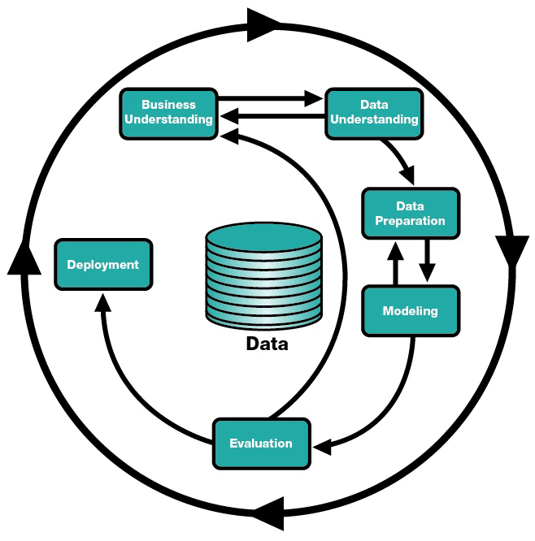

## **Problem and Motivation**

## To begin our research of the provided information and datasets, we observed the need for further cleaning and processing due to multiple instances of the redundancy. Our initial task targeted dysfunctional data which took many different practices such as apply merge, text-to-columns technique in excel, and most importantly remove auxiliary rows, attributes and instances. This process increased our awareness of each dataset, as we had to familiar ourselves with its purpose, what it contains, and which attributes out of it are best suited to help us in our analysis. Additional discussion of challenges faced, the preprocessing techniques applied, and the evaluation of all the datasets is given in greater detail later on in this report.

## **Approaches**

## After the preprocessing of data, we did an initial visualization of the data to explore and understand the existing trends, and gradually answer the questions. Some of the questions required the combination of data from multiple datasets, thus it was necessary for us to integrate them in order to to arrive at our conclusions and recommendations. Primarily we used TABLEAU for visalizations, in addition to WEKA and IBM Watson for visualizations and analytics.

## **Results**

## By initially focusing on assessing the business related questions put forward by the client we generated various results which were deduced from each of the datasets. We then investigated these further to develop additional understanding from previously unconsolidated data. These additional insights are evaluated along the key recommendations and conclusions developed throughout our analysis.

## 

## 

## 

## 

## **Part I: Business Understanding**

## National Multiple Sclerosis Society (NMSS) is a non-profit organization based in New York City with chapters located throughout the United States. The organization funds disease research, advocates for social and political change, facilitates professional education, and provides programs and services which help people with multiple sclerosis and their families. The Society is dedicated to achieving a world free of MS.

The organization supports all of these activities through a variety of fundraising programs. It’s flagship event is Bike MS which it advertises as the premier cycling series in the nation. Each year the program cumulatively engages over 70,000 participants in more than 75 team-focused events which take the form of bike rides held at various cities across the United States to raise approximately $68 million.

The program’s structure places increased value on corporate teams, as events typically attract a predominately male, middle-age, higher-income bracket populace. As teams are responsible for 87% of all fundraising efforts, corporate teams made up of 10 or more cyclists have a value seven times greater than any other type of team. This makes firms with a large professional employee base, whom additionally support and embrace a corporate culture of health and wellness, the key targets for participation.

Although the program has maintained a relatively high retention rate, over 50%, it has struggled to procure new participants in recent years; this has resulted in a constant decrease in overall participation and subsequently revenue since the event’s peak in 2012. This is due, in part, to the increased competition stemming from other bike charity events.

While it is standard practice for team captains to be recruited by staff and volunteers early on in an event year, additional team members are normally solicited by someone they know, and not the organization directly. Typically, teams of at least ten riders raise three times more than smaller competition groups. Thus, the ability of an event to meet its fundraising goal is heavily impacted by the recruiting skill of participating captains and the dedication of their team.

In 2017, Bike MS events registered 74,000 riders across 6,150 teams; 1,561 teams had at least ten members and of those, 642 could be classified as corporate teams. For 2018, NMSS seeks the participation of 6,489 teams made up of 80,575 riders; specifically 40,000 new cyclists who have not participated within the last five years of events. To do this, the organization must gain understanding and awareness on how the digital marketing efforts, which are strong in some markets, impact acquisition; and ultimately use this to target new corporate teams.

This report uses relevant documentation, datasets, and a data dictionary provided by Bike MS and NMSS to identify and relate existing gaps and missed opportunities to past performances and gain insights. This analysis can then be used to generate a predictive model and reverse the inauspicious trends that are currently impeding the performance of Bike MS events.

Our evaluation of NMSS, in regards to its Bike MS events, has divulged a number of ways in which predictive analysis through data mining and business intelligence techniques can confront the fundamental problems inhibiting further success and growth of Bike MS events:

* What is the overall value of investing in digital advertising?
* What corporations have the team captains with the best recruiting records?
* What tactics and behaviors drive fundraising?
* How do our fundraising tools relate to the performance of top fundraisers?

Throughout this report we will go through the processes which we used to analyse the data, what additional information we needed, where we found connections between provided datasets, and what insights we were able to observe. We will conclude with a presentation of our findings and recommendations on how the organization can realign some of its operations to take advantage of new markets and growth opportunities.

## 

## **Part II & III: Data Understanding/Data Mining Evaluation**

NMSS made several datasets available for the challenge. Understanding of the content of these datasets was critical to answer the questions asked by NMSS. As data pre-processing progressed, the preliminary mapping of datasets to these questions were revised several times.

A recurring theme was the need to combine understanding from different data sources to obtain the best insights. For example, the team gave a number of participants per team and the participant a table linked these to the value and number of donations made by that participant. The events table gave both location, and regional, details of each event which could be linked to the donations. In addition, gaps with knowledge were identified and external data was sourced to supplement the analysis.

Common data issues and the solutions adopted included throughout our evaluation were:

* Variable use of date and time fields which were separated and formatted for consistency in English (United States).
* Multiple variations of same (or very similar values) for the same or like attributes which benefited from being cleaned for consistent and concise analysis. Examples included: “participant connection with MS”, “donor connection with MS”; “team division”.
* Attributes that were essentially duplicates of each other. For example, the “soft credit type” and “proxy type” attributes in the Donations data set and Member ID and Contact ID in Donations and Participants data sete. In each case one attribute was removed for the purpose of analysis.
* Instances that were entered to test the system and had no real data were removed from the data set.
* Attributes that had very high rates of missing values were removed.
* Attributes that did not add to the data analysis task were removed.

More specific issues identified with the individual data sets and pre-processing decisions made are included in the summary or our preprocessing techniques below.

***Donations***

This consists of separate spreadsheets for each fiscal year from 2013 to 2017.

Instances:

Each instance records a ‘donation’ made in the fiscal year. The dataset combines different domain areas which derive from the way the donation website is laid out including linking the donation to a specific event, team and participant, recording demographic details about the donor and details of acquisition source.

Attributes:

There are 44 attributes: *security category name, event, ID, public event name, fiscal year, event data, event title, campaign, ID, gift amount ($), date recorded, gift type, gift payment method, offline status, soft credit type, recorded, is registration? donor cons, ID, donor member, ID, donor affiliate code, donor gender, donor accept email, donor opt-out date, donor opt-out method, donor email status, donor city, donor state, donor county, donor ZIP, donor employer, donor connection to MS, participant contact, ID, participant member, ID, participation type name, registration active status, registration date, participant goal ($), is prior participant, is team captain, additional gift amount ($) team name, team, team creation date, original value transacted, net transaction amount, ledger transaction amount, proxy type, user confirmation code, source code type, source code text, sub source code text, batch ID.*

Significant links from this data are Event details, team details, participant details.

Data quality and pre-processing:

The donations data has been compiled from a number of different sources and suffers from high level of misaligned fields in the right side of the data sheet.

Even after the number of attributes had been culled, The size of these datasets made it impossible to amalgamate data together. Several options were considered to address this, including sampling. To assist this decision, descriptive statistics for the five donations datasets were compiled to look at metadata based on the Gift Amount which was chosen as a key attribute with little missing data.

The presence of a donation outlier (the maximum value), for each financial year which was two to three times the size of the second largest donation was noted. As this was always associated with the same event (Bike MS Harmons in Utah) but not with any particular team, it was flagged for removal when evaluating team performance.

The data demonstrates that the donations recorded have declined from the peak in 2014. The primary relationship with a decline in the total number of donations is clear. There has in fact been an increase in the average donation over the same time. It was noted that there was a high number (between 5% and 9%) of zero values for gift amount. It was noted that these instances were all classified as registration events (“is registration?” = YES) and contained dollar values for original value transacted.

Recalculating the mean value for amount per participant after removing these ‘not donations’, confirms that 2016 was a particularly poor year for donations but that there had been some improvement in 2017. The conclusion is that the donations dataset is NOT just about donations and that clearer intelligence could be forthcoming for NMSS if they restructure this aspect of their data.

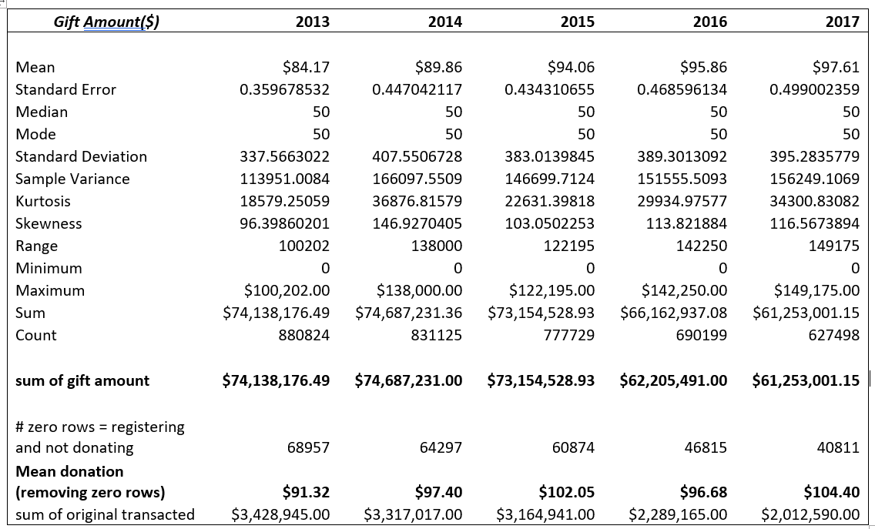

***Events***

This consisted of a single datasheet covering the period from 2013 to 2017.

Instances:

There is one instance for each bike ride event which takes place.

Attributes:

There are 26 attributes: *fiscal year, event, ID, security code, public name, created date, event date, event location, goal, active/inactive registrations, total fees paid, total of all confirmed gifts, online gifts, # of teams, # of captains, average team size, team pages, emails sent, total offline confirmed gifts, # of self donors, total from participants, non-self donors, total not from participant, total team, total event, and total offline confirmed gifts.*

Data quality and pre-processing:

The total of all confirmed gifts = sum of transactions (gifts) for that event, but these may not reconcile with the sun of transactions in the transactions report.

Events that do not have event dates are classified as “test events” (created for the purpose of testing various functions and updates but have been arbitrarily left in the system); these instances have been removed from the data

Time and data were separated and formatted

The first three characters in the attribute “security category name” have been, identified as an affiliate code; a version of these characters has been separated and saved as an additional attribute titled “Affiliate Code” to be able to regionally classify events.

***Participants***

This consists of a single datasheet covering the period from 2013 to 2017.

Instances:

There is one instance for each participant for the events held between 2013-17.

Attributes:

There are 39 attributes in this dataset: *security category name, fiscal year, internal event name, event date, participation type name, team name, team creation date, team, ID, contact ID, member ID, participant accept email, registration date, registration active status, is team captain, is secondary registration, is prior participant, emails sent, total of all confirmed gifts($), total from participant($), total not from participant($), number from participant, number not from participant, participant email status, participant employer, participant occupation, participant connection to ms, address - participant state/province, address - participant county, address - participant city, address - participant zip/postal code, registration type, event, ID, participant gender, participant goal($), suggested participant goal($), source code type, source code text, sub source code text.*

Data quality and pre-processing:

Data Cleaning tasks included categorising registration types into 3 primary categories- Cyclists(majority),Virtual participant & Volunteers (Caveat; All types that were not categorised as Virtual participant or Volunteers are defaulted to cyclists).

* Member ID is for Master Db and is not same as Contact ID, which is unique, ID for all online transactions and used for all interactions related to Bike MS.
* Prior participation indicates participation in previous iteration of the event
* Total Confirmed Gifts: Gifts received and processed by NMSS, total from Participant & Total Not from Participant include non confirmed gifts (recorded but not actually received by NMSS)
* Number from participant:Donations made by participant: and Number not from participant:Donation made on behalf of participant.
* Registration Type:Online / Offline donations.

Initial Visualizations to observe and understand the trends over time for various attributes were performed through Tableau and IBM Watson. Following on from the basic information from visualizations, deep down analysis was performed for certain interesting trends to come up with possible recommendations. Predictive models developed for relevant attributes showing interesting relationships between values of certain attributes with help of decision trees post preprocessing the data and removing few non-relevant attributes for that specific analysis to reduce processing time and reduce complexity of the model.

***Bike Teams Data Set***

This consists of a single datasheet covering the period 2013-2017

Instances:

There is one instance for each bike “Team ID” noting that a bike team is given a new ID for each event it is registered in. The name of the team may remain the same.

Attributes:

There are 26 attributes in the dataset: *event type, internal event name, event id, team id, team name, team creation date, team captain contact id, captain email domain, team captain, accept email, team division, company, number of participants, total fees paid, team total confirmed ($), total online gifts($), total offline confirmed gifts($), total offline, unconfirmed gifts($), team goal($), total confirmed gifts in team history($), previous event fiscal year, previous event internal name, previous event team name, previous event confirmed gifts($), previous event team members, event date, fiscal year.*

Data quality and Pre-Processing:

The most important attribute here is Total Confirmed Gifts in Team History which tells us the sum of total offline and online confirmed gifts. Previous event year, Previous Team Name, Previous confirmed gifts all describe the statistics if the team has participated previously. For primary data preprocessing, we cleaned the data by removing all the special characters (‘, ‘’) and replacing them with NULL. This is for pushing the data to TABLEAU. Also, we separated out the day/month and year to different columns. This could help us to visualize according to a particular year/month. There were a lot of NULL/missing values and as they were nominal values, they should be ignored.

An initial visualization of the data revealed that the most important attribute here is the total confirmed gifts in team history by the teams. We use this measure as the the base and find trends for corresponding dimensions for analysis of trends, which are - Event Year. - This showed us that the corporate team revenue increased in the year 2013 and then constantly started decreasing.

By graphing the total confirmed gifts by total number of participants, we see an interesting insight where the participant numbers do not affect the team’s confirmed gifts (donations). We see that the team’s revenues are greatest with participant numbers between 9 to 30. Beyond that the numbers keep decreasing.

***National Teams***

The National Teams dataset related to an society wide initiative to engage companies across multiple bike events and markets. The dataset was not normalised.

Instances:

There is one instance for each local team that participated as part of a national team.

Attributes:

There are 27 attributes: *national team name, event chapter, event category, event type,*

*local team name, event name, event start date, location, corporate name, revenue raised, number of team members, member id, contact id, email domain, bad email flag, contact by email ok? (y/n), phone type, call status, contact by phone ok? (y/n), city, state/province, zip code, bad address flag, contact by mail ok? (y/n), active flag, deceased flag, primary connection to ms,*

Interesting Attributes:

* Event Type - This determines the type of the event under the bike category. Local Team Name - This defines the local team name in the particular state. This might be different from the overall national team name.
* Revenue Raised: This attribute tells us about the total revenue raised from the particular team. This is grouped by national team name.
* Number of Team Members: This determines the number of team members.
* Contact by email (Y/N): This tells us if the team captain can communicate through email.
* Bad Address / Bad Email flag: This is a binary attribute which tells us if the address or email of the particular team captain is incorrect.
* Connection to MS - This tells us how these team captains were linked to MS - either through Friends/Family or Relative, or he/she does not have MS.

This dataset needed cleaning because the first column which had the national teams name had merged cells and they needed to be separated out. After cleaning was complete we used TABLEAU for visualization of the data and used Data Interpreter function there to populate all the NULL values efficiently.

***Bike MS Digital Advertising Reports***

This data set comprised a workbook and summary reports covering advertisements run on different platforms. It is generally organised by financial year and location, but formats have changed over time.

Instances:

These are variable, as much of the data is pivoted. Data covers advertisements run over a period of time (2015-2017).

Attributes:

Interesting attributes are:

* DATES which comprises of Start date and End date of the advertisements run
* Target CPA is a strategy which helps in getting as many conversions as possible at the targeted cost-per-acquisition
* Impressions are when the advertisement shows in front of the user, GROSS CPA is cost per acquisition per registration
* Click through conversion is conversions is how many times the "paid" visitor finishes the task. They click on the ad, register and convert
* View through conversion is when the customer sees your add but returns later and converts
* Target Conversations made within a certain budget, Clicks is the number of times someone clicks on the advertisement
* CTR is number of people that see your advertisement after looking at it
* Platform is categorized by Social, Display and Search
* TOTAL spend is the amount spent in a time period or for a city or on a platform.

Data quality and pre-processing:

The dataset was as clean to enable the best insights; to do this the DATES attribute required segregation and formatting to enable daily/monthly/yearly insights. The 2016 and 2017 dataset was joined to enable comparative analysis. A few cities hadn’t ended the advertisement campaign at the time of dataset preparation. They were excluded from analysis. An initial visualization of the data reveals that the most important attribute here is the Gross CPA (cost per acquisition per registration), Impressions and TOTAL SPEND (date/city/platform). The graphs drawn using TABLEAU shows the the greater the inverse relationship between GROSS CPA and TOTAL spent, the better the ad campaign.

***Google Analytics***

These data sheets provide data about the Bike MS website. The funnel conversion model was also used to better understand the user-website interaction.

The Datasets are classified under four goals-

* GOAL 1: Individual with payments
* GOAL 2: Start new team
* GOAL 3: Join Team
* GOAL 4: Join Team from team page

The instances are based in on default channel grouping. The important attributes are Default Channel Grouping informs us the source from which the user has entered the website (Default Channel Grouping, Social, Referral, Paid Search, Organic Search, Email, Display, Direct), Sessions is a group of interactions a user does before leaving the website in a given period of time, % New Sessions is the new interaction by a user after certain amount of time, New Users are the ones with no cookies pertaining to the website that is these are the actual new users. Bounce Rate is the % of users who leave the website after visiting one page, iPages / Session Avg. Session Durations the average time per session user spends on the website.

Data quality and pre-processing:

The four goals had individual datasets with the same set of values. The redundancy had to be removed. The missing values were taken care of. The data belonged to only 2017 . The states and cities were mixed for the location based dataset. The states were standardized into cities based on donations, participants and advertisement datasets. As the dataset was a general google analytics data, it involved a lot of unrelated global instances and labels. They were handled to have a more directed/channelised approach to visualizations.

## 

## **Part IV: Analysis of Models**

Corporate Acquisition

**Growth Opportunities for Corporate Teams**

We first tried to break down this problem by finding where do we get new corporate teams. We saw that the Bike Teams dataset and we filtered the data according to fiscal year of 2017 (latest) and we found out only the corporate teams out of them by filtering it on the Team Division attribute. After filtering them, we pushed the data into TABLEAU. We found these insights -

We saw that the Red Hat Open Cycle event is producing the same Previous event Confirmed Gifts and Total Confirmed gifts in team history. So, Bike MS should focus on promoting this event more so that it retains its fundraising capabilities and also tries to lure participants.

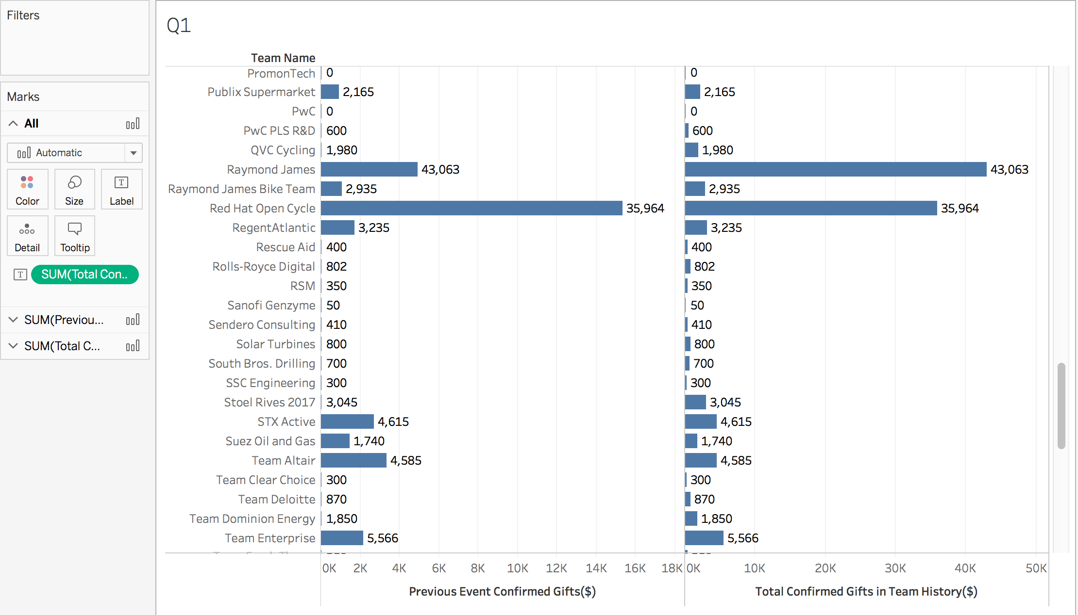

Also, we know from the National Team Activity dataset that the maximum revenue comes from the state of Texas. Bike MS should realize that as the maximum revenue comes from the state of Texas, it should promote its events more there. This is the description of the graph of what are the events happening inside Texas.

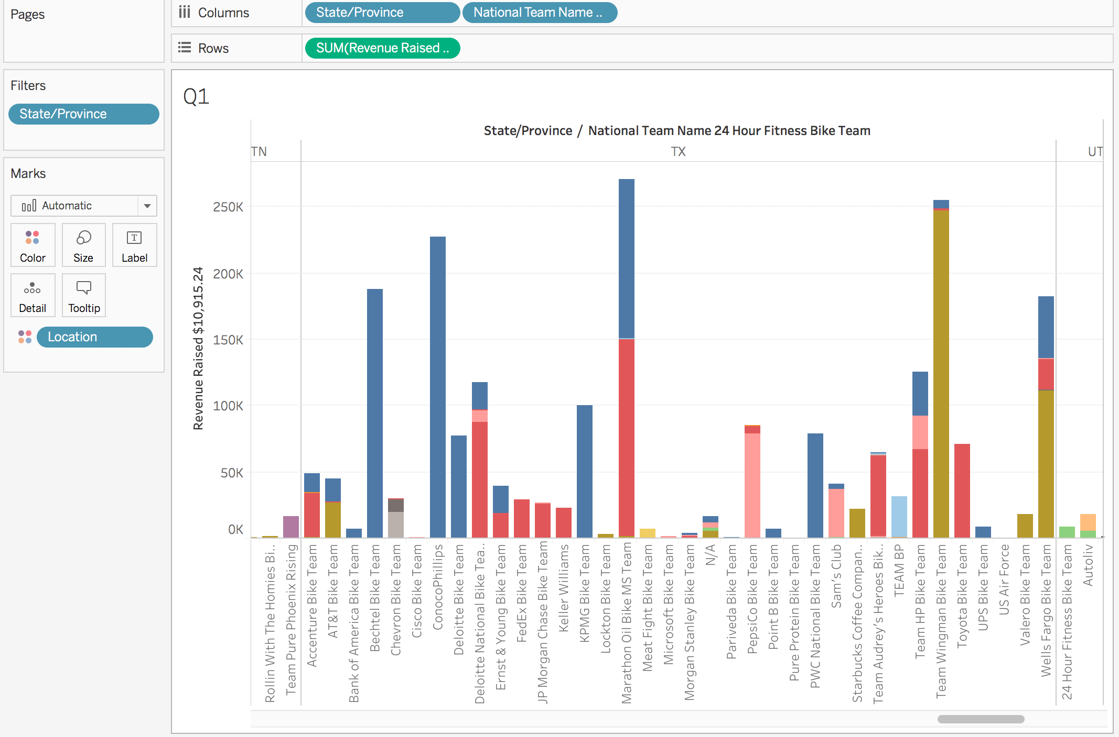

From here it should focus on *Oil and Gas company sector* more as the highest gifts donated / fundraised comes from them.

This is also showed in the visualization below where we saw that the biggest city generating revenues in Texas is Houston to Austin. We find the team names which generate the highest revenue.

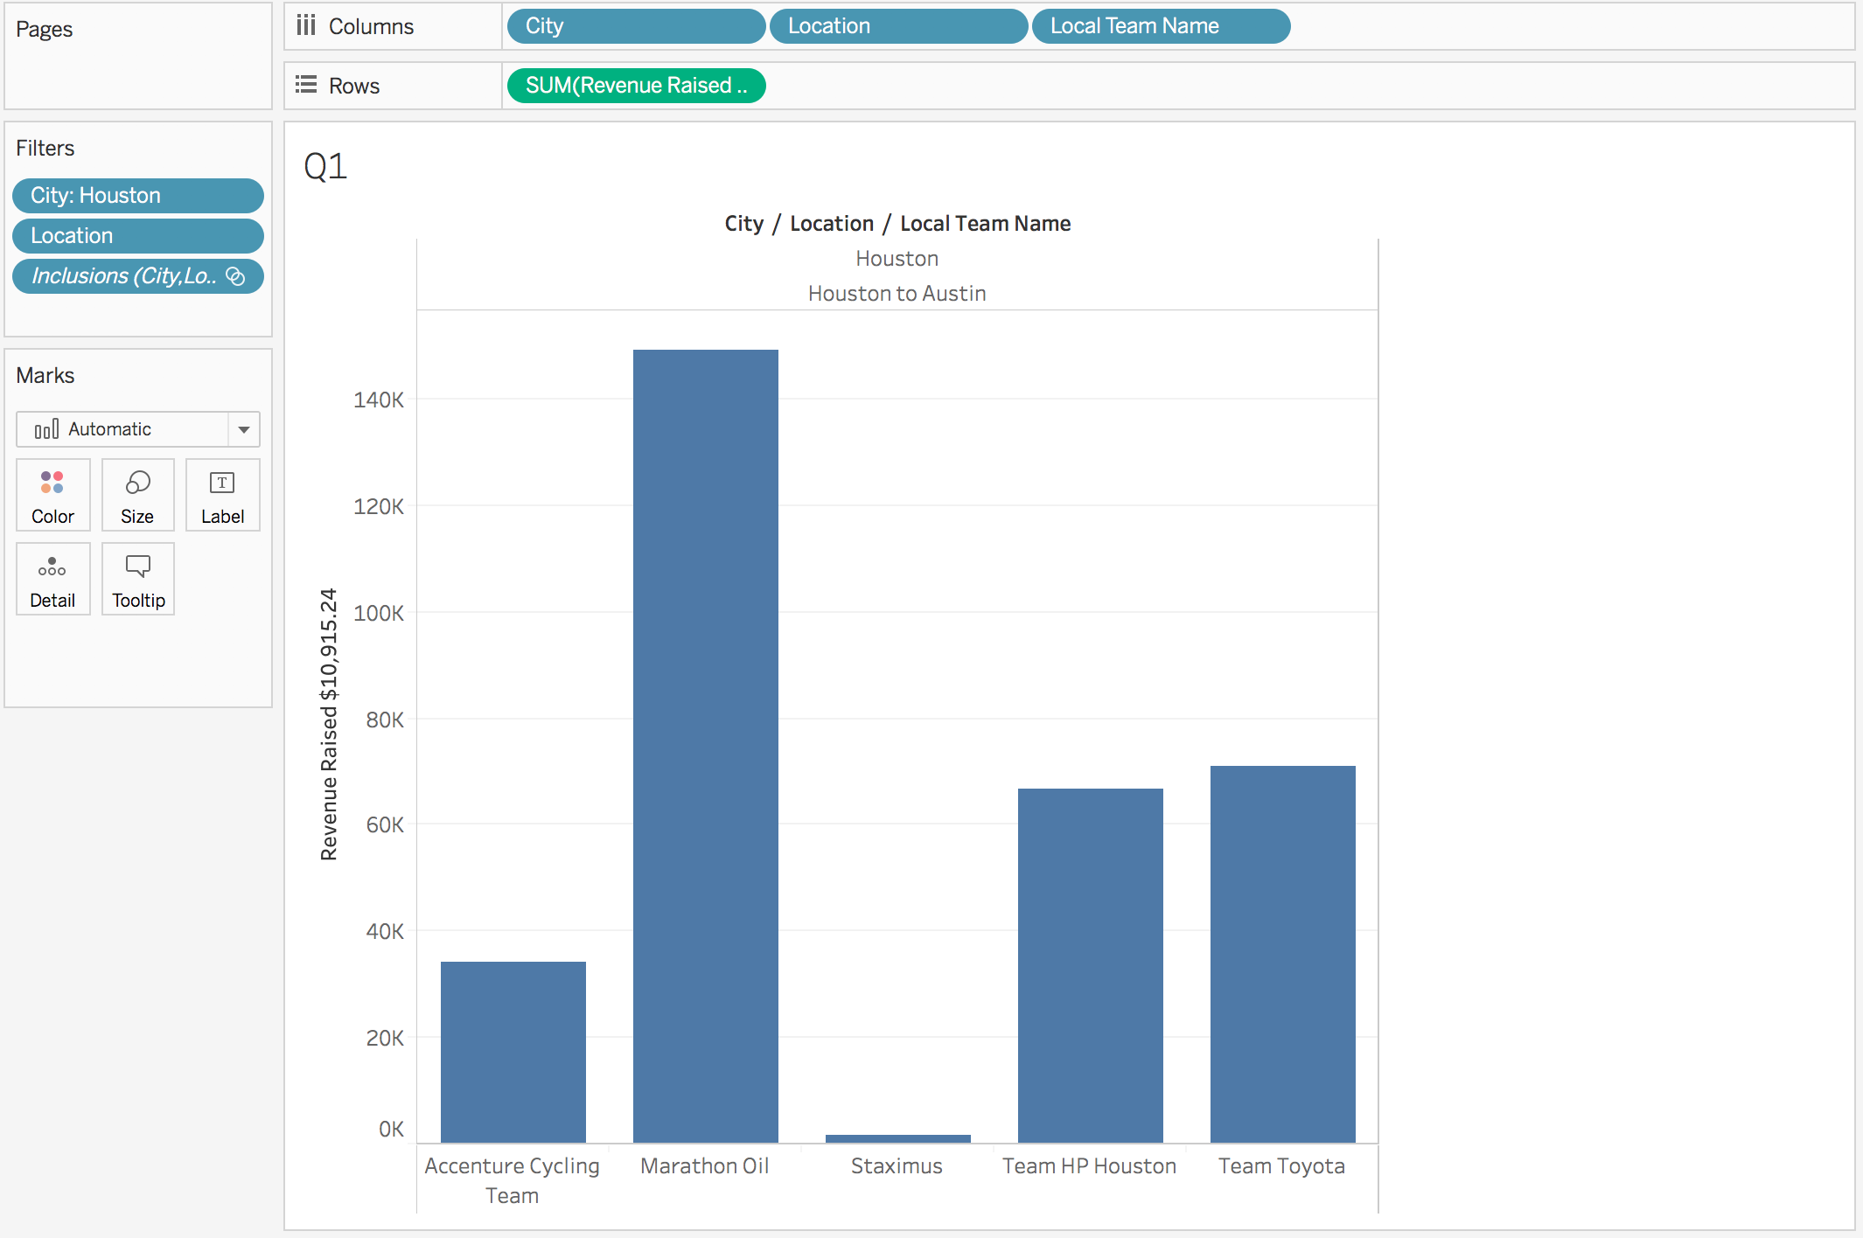

**Application to Popular Events**

Application of the insights gained from the aforementioned evaluation of corporate team indicates that the biggest growth opportunities for new corporate teams is outside of Texas. Although the events in Texas do that have largest revenue, there are copious teams to be creates and funds to be raised in other geographical regions of the United States.

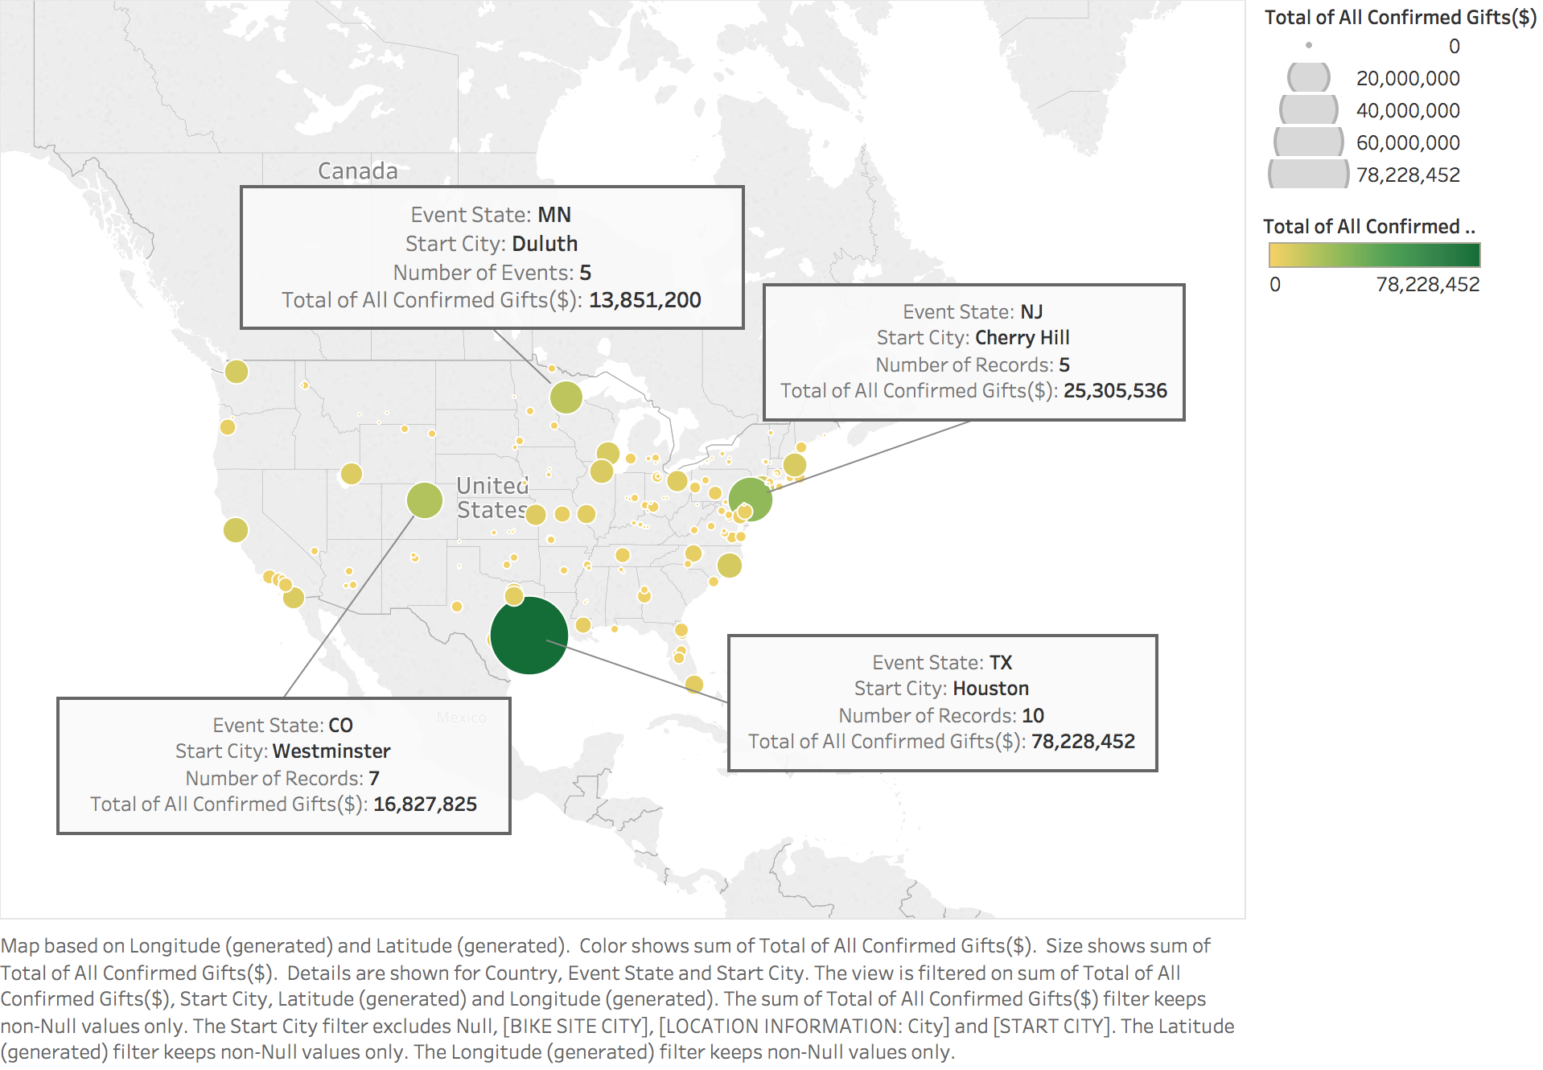

The annotated map above illustrates three additional growth opportunities in Cherry Hill, NJ; Westminster, CO; and Duluth, MN; these states are previously unrealized chances to promote and attract corporate teams at Bike MS Events. Each of these cities have past success in meeting their event fundraising goals and have maintained a lead close behind Houston, TX.

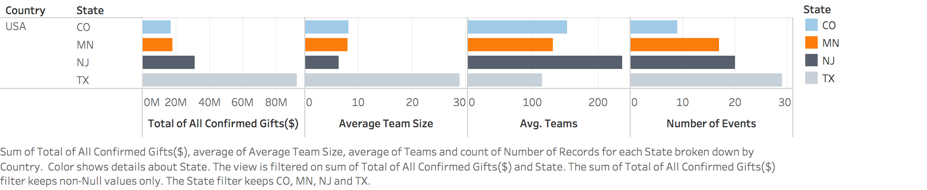

The above chart shows that while Texas does lead the events in many attributes, there are a few states close behind, and with the right focus, NMSS can promote corporate sponsorships and teams to create the best environment for the event to be successful.

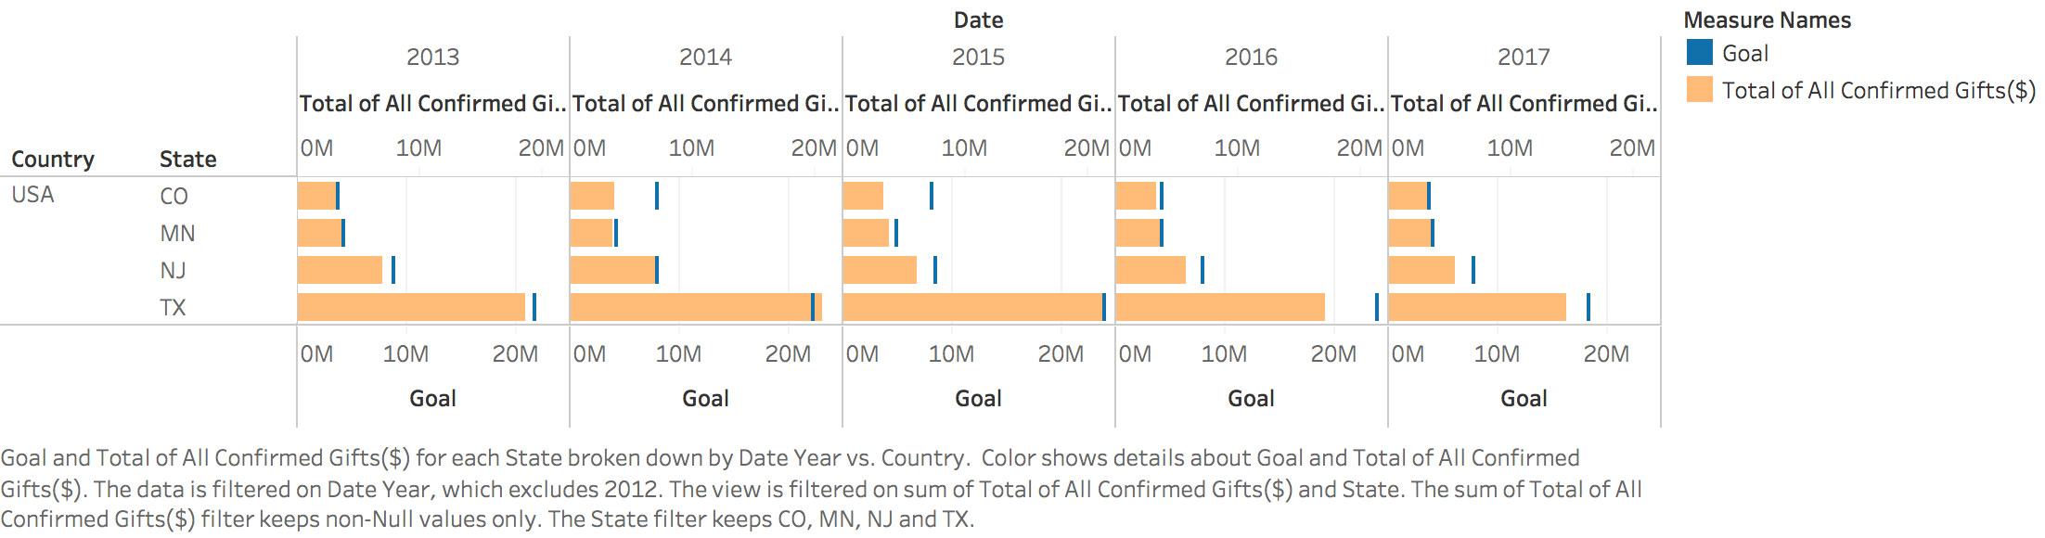

Minnesota, Colorado, and New Jersey all have a history of raising sufficient funds at events; with the right marketing and partnerships, the events held in these states will eventually right to the level seen in Texas. Focusing on these markets will additionally allow Bike MS to navigate away from the highly competitive markets it is in now; this will make the organization more capable of meeting its ultimate mission and goal.

**Prevailing Industries**

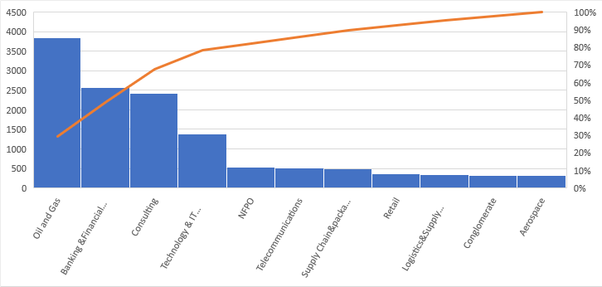

Looking at the Top 25 Organizations in terms of their numbers of participants over the last five years from 2013-2017 and co-relating them with their industrial backgrounds, we can see that Oil & Gas, Banking & Financial Services, Consulting and Technology(IT) sectors creates the bulk of the supply as per the pareto chart above.

In terms of Number of individual firms from each sector we see that the Oil and Gas sector contributes the maximum with 6 companies from the sector making it to the top 25 closely followed by Banking & Financial services. In terms of awareness about the Bike MS events, these sectors can definitely be looked at, considering their overwhelming contributions over the last few years. So this is a good opportunity for pushing the envelope even further by using these brand names as collaterals to attract more participants from companies belonging to these sectoral backgrounds.

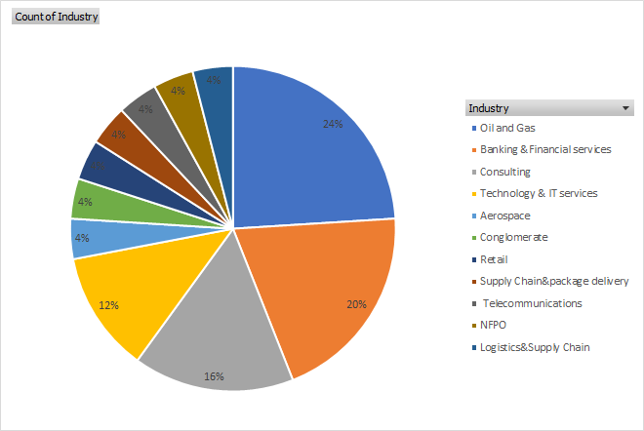

**Powerful Occupations**

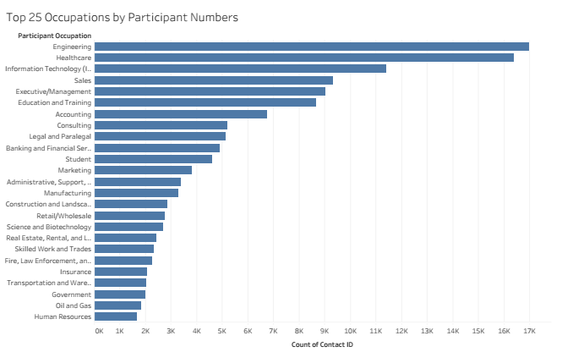

The Chart above gives a snapshot of the key occupations(Top 25) in terms of their overall contribution to the Bike MS events over the last five years 2013-17.Engineering , Healthcare and Information technology make up the top three occupations , probably leading us to look more closely at either their economic backgrounds (Financial Statuses due to their occupational backgrounds) or their awareness and willingness to contribute towards social causes.

**Common Denominator in Corporate Teams**

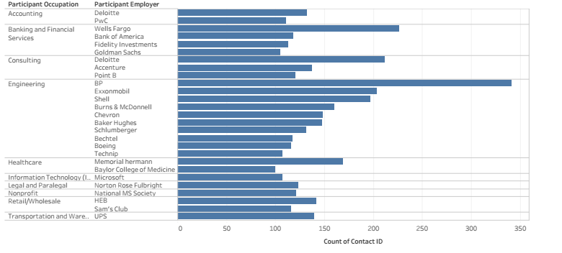

The graph above shows the occupation wise key Employers , with a minimum contribution of 100 participants and above from each combination of Occupation and employer.

So, we can visualize here that Deloitte and PWC are the key contributors for the Accounting professionals participating in the event over the last five years so the event has a decent brand presence within specific occupations of particular companies and can be further cashed in through targeted advertisements in these pockets to create better conversion rates. Also, these pockets can be studied more closely to see their correlation with events like Bike MS and model developed to penetrate similar pockets in other sectors.

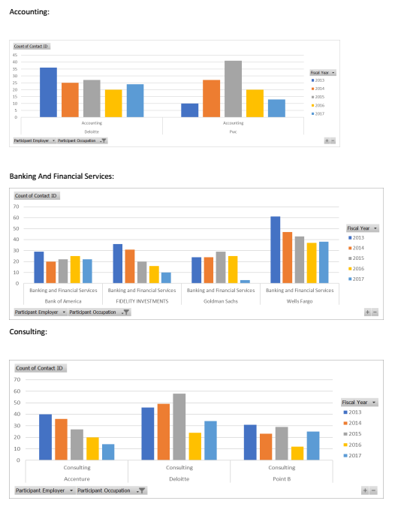

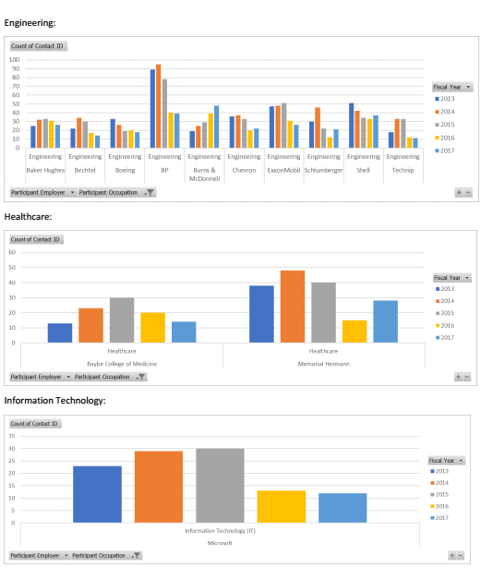

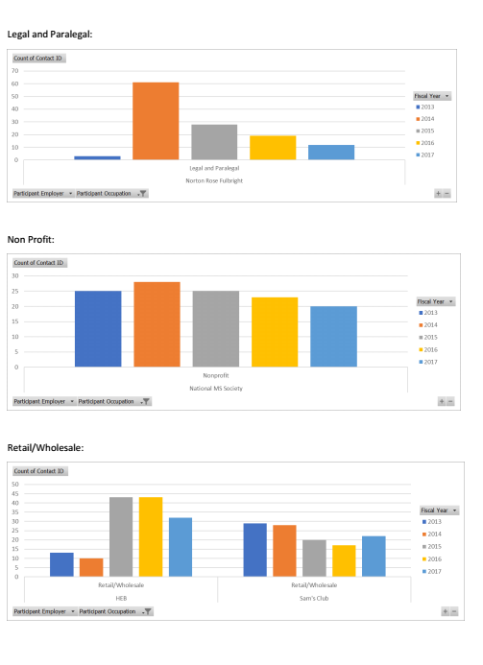

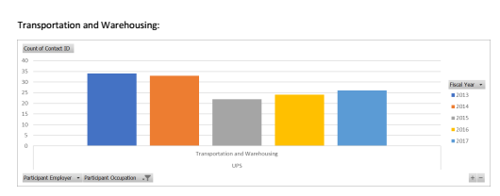

Thus from the above graphs, we can clearly see the changing trends over the Years for the most High performing combinations of Occupations and employers and create marketing plans basis the gaps identified in terms of declining numbers from the high performer’s Bracket. (Combination of employers and occupations, each combination contributing at least over 100 participants to the events over the last 5 years 2013-2017.).

For Example, if we consider Accounting as an occupation: We find there are two employers Deloitte and PWC contributing the maximum number of professionals and their individual trends (no. of participants) over the period 2013-2017 can also be observed. Both Have exhibited an overall decreasing trend over this period so accounting professionals from these two firms may be targeted through various channels like referrals, targeted campaigns, emails, direct sales calls etc to increase their participation for the events as the propensity for such conversion seems to be high from the available data. Similarly, the trends for other occupations like Engineering, IT etc can be analysed to arrive at the target segments for dedicated campaigns.

Then, we opened the National Teams Activity Dataset, which consists of all Corporate Teams. We check the top performing teams as measured by revenue raised. We compare that with “Primary Connection With MS”. Then we get that the most revenue raised from the category of “Friend has MS”. Then we go deep into it and have these insights –

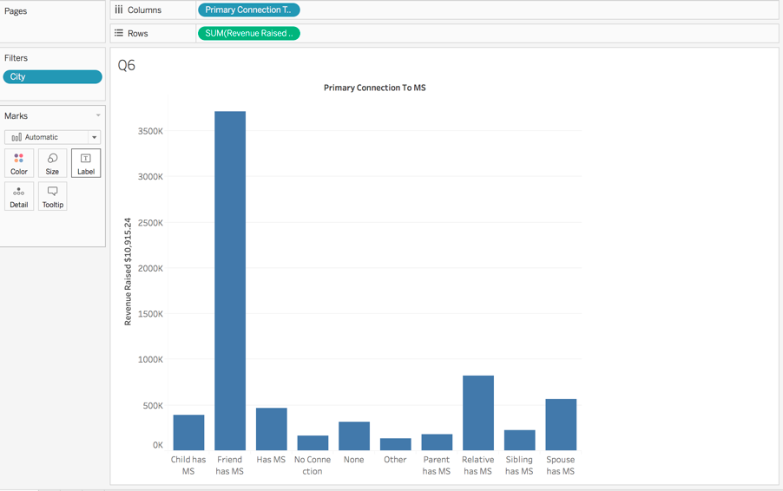

We see that Texas produces the most revenue and we start digging deep into it. We sort it by the National Team Names and we see that the highest revenue generating corporate team is Marathon Oil Bike MS Team.

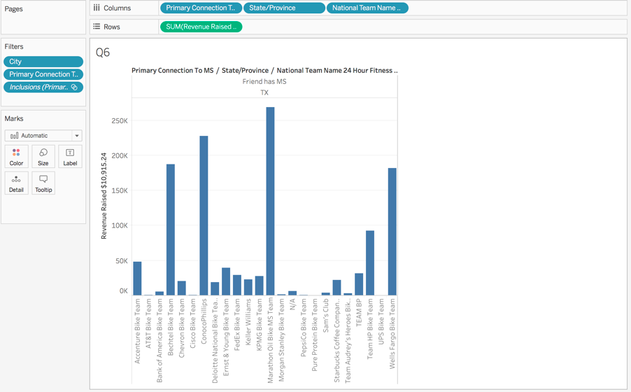

We then try to find the highest revenue generating national teams name then clustered the results, we see that they represent the two industries – Deloitte & SalesForce.

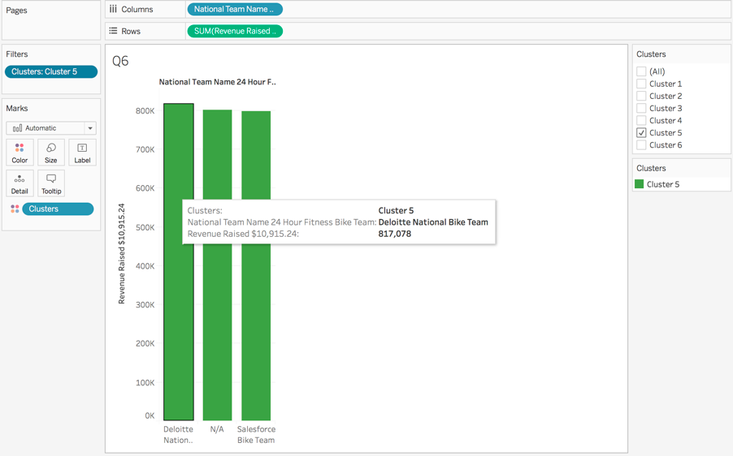

We see that the majority of teams do not have a work phone, which explains the fact that there is no executive involvement.

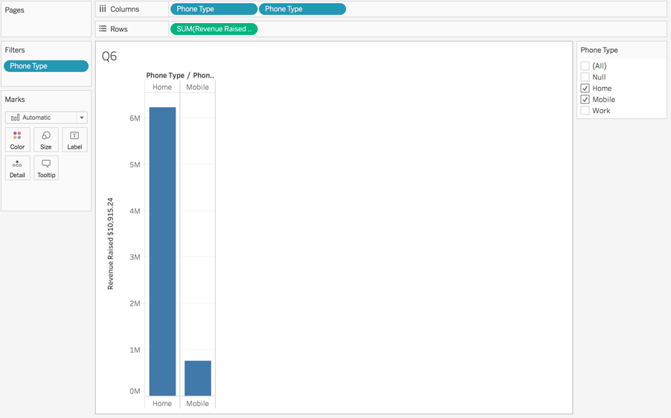

**The Impact of Competing Markets**

After analysing the internal data compiled from Bike MS Events taking place from 2013 to 2017, we have extended our investigation to additionally consider the effects that competing events are having on the organization’s top markets. Fundraising through bike events has become a popular means of raising funds and awareness for a variety of charitable programs; each year major campaigns such as Best Buddies, Pedal the Cause, Pelotonia, JDRF, the Pan-Mass Challenge, and the Cystic Fibrosis Foundation plan events similar to those run by the National Multiple Sclerosis Society (NMSS) to raise money for their various causes. By researching and obtaining additional data on the events organized by competing organizations, the external impact from these competing events can be discerned. From here, recognizing where and how these events are experiencing success can result in better planning and operation for future Bike MS events.

Evaluation of the schedules and schemes utilized by other organizations will reveal additional opportunities for NMSS to transform its events. Differentiating its events from its competitors will allow Bike MS and navigate its way out of the crowded charity cycling space.

Not all of bike fundraising programs are directly comparable, due to wide variations in the number of rides, the use of teams, and fundraising commitments. Bike MS is able to stand out against a large number of competitors simply because of its size; operating 75 rides in nearly each of the US States and mobilizing over 70,000 participants to raise approximately $68 million to help support its mission of a helping people affected with MS to live their best lives, and supporting necessary research into treatments and cures as they strive to achieve a world free of MS.

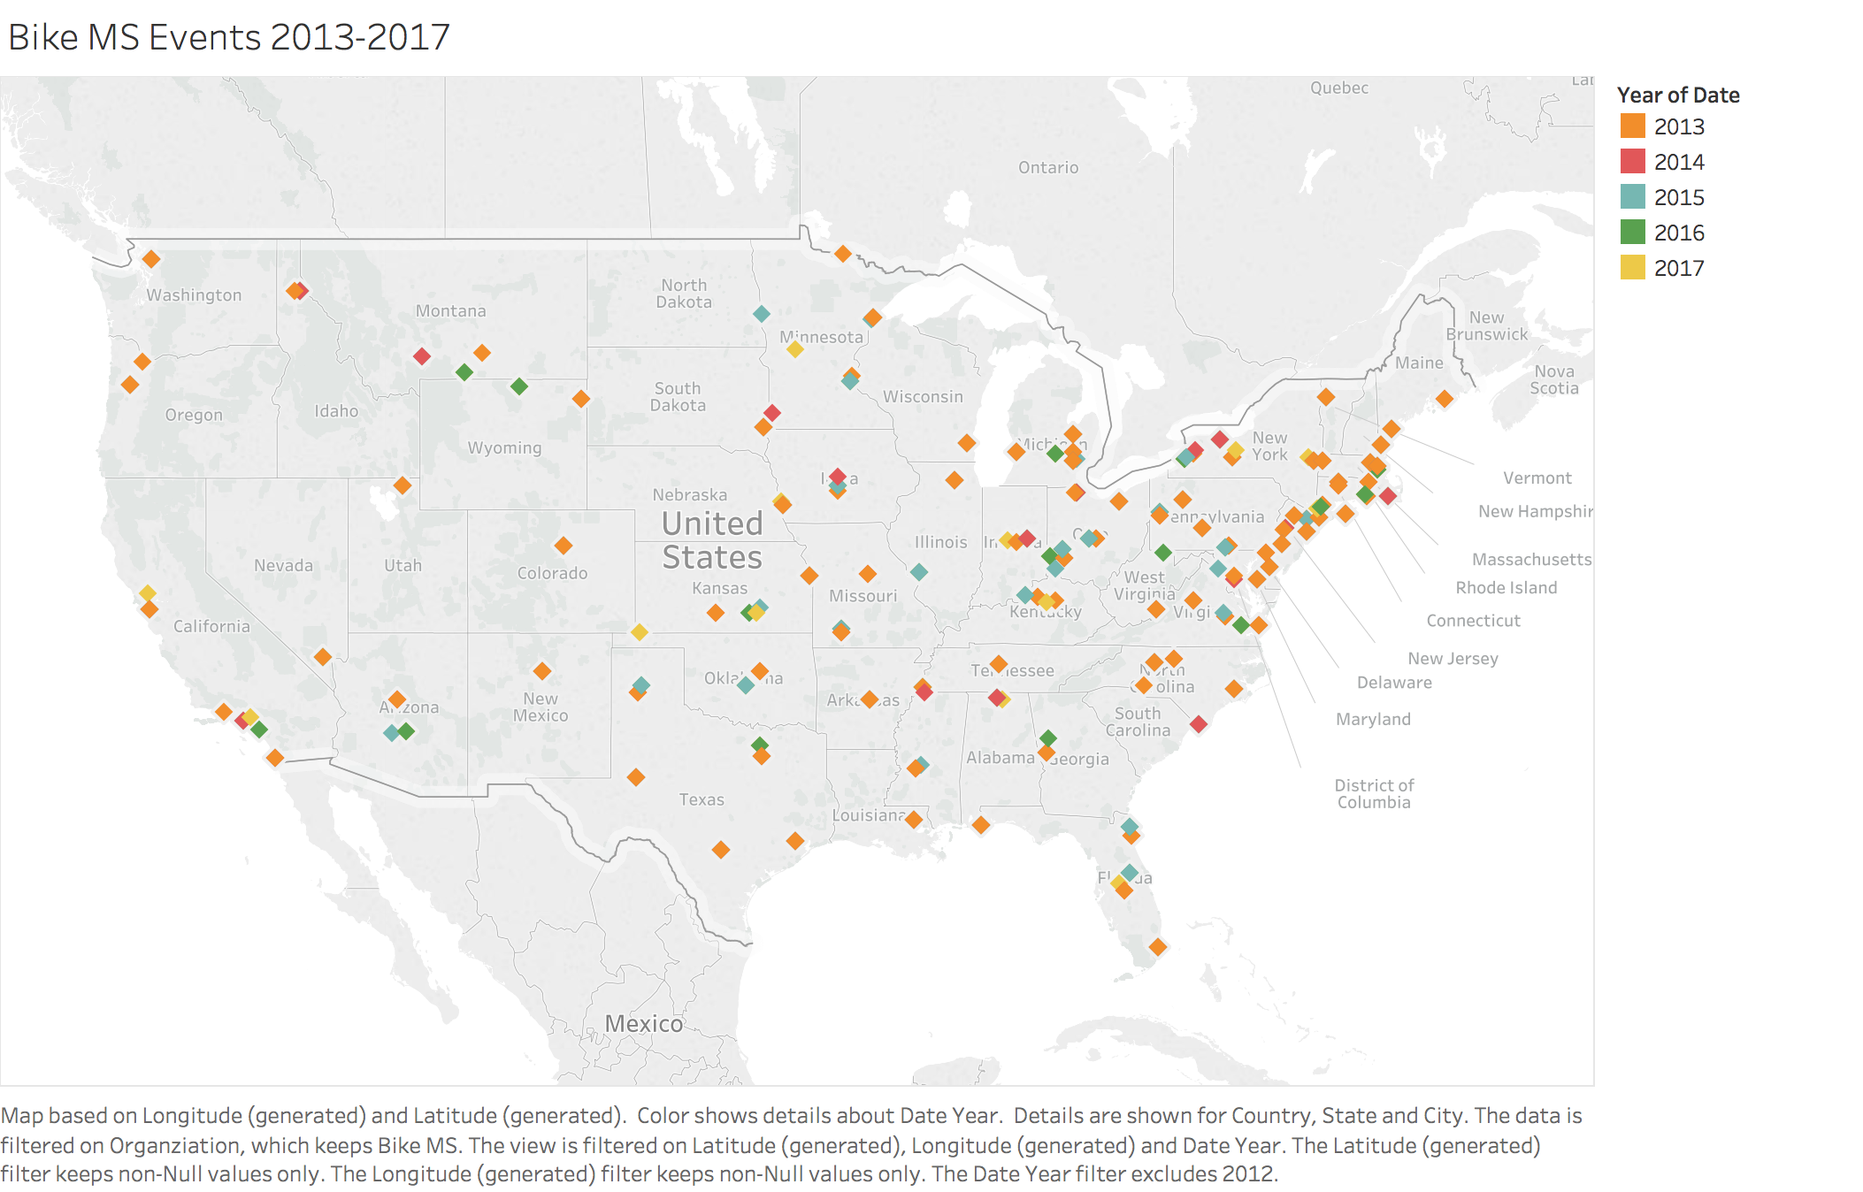

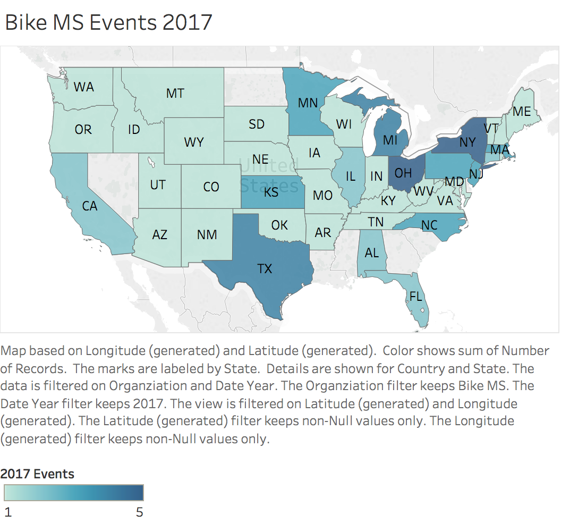 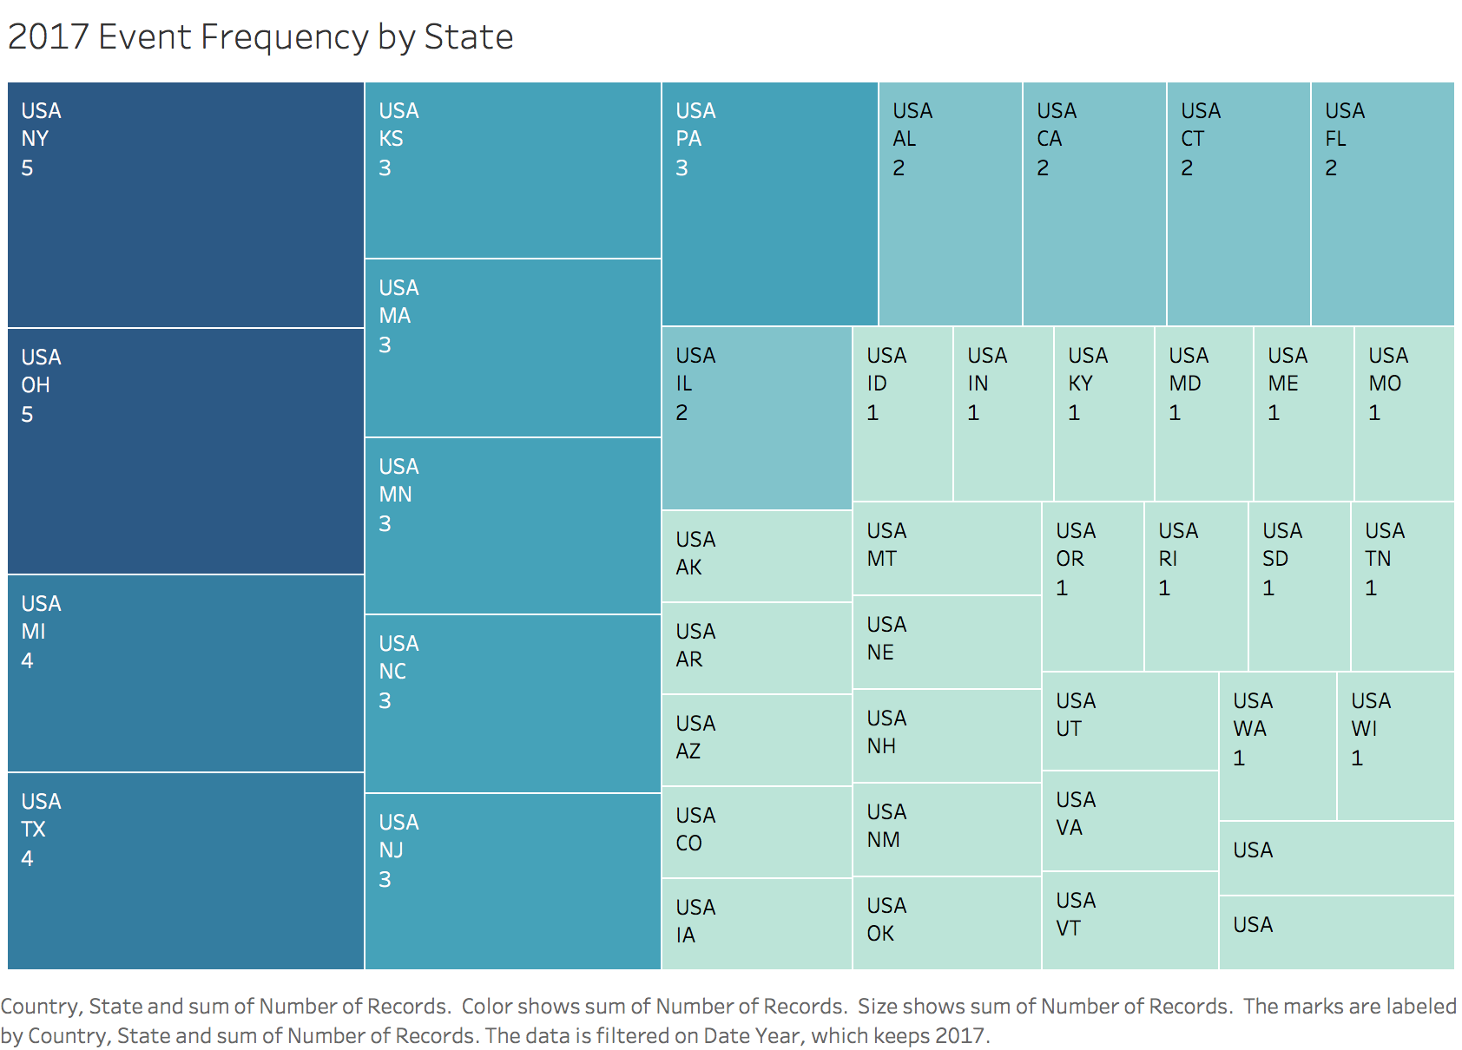

While the majority of its competitors limit their efforts to a few events each year, Bike MS put on 73 different rides in 43 different states throughout 2017 alone. This diversification of regional areas enables the organization to better attract cyclists by making events available to all; cyclists will have opportunities to participate in events close by and thus the prospect of having to arrange for travel will not deter individuals.

Bike MS’s biggest competition in the market is from the Cystic Fibrosis Foundations bike charity ride which is similar in operation as well as schedule; in 2017 CF Cycle for Life raised nearly $3.5 million from its numerous events. In 2018, the organization has arranged over 40 events that take place across various states. The graphic below the various bike events from Bike MS and its main market competition which take place in a calendar year.

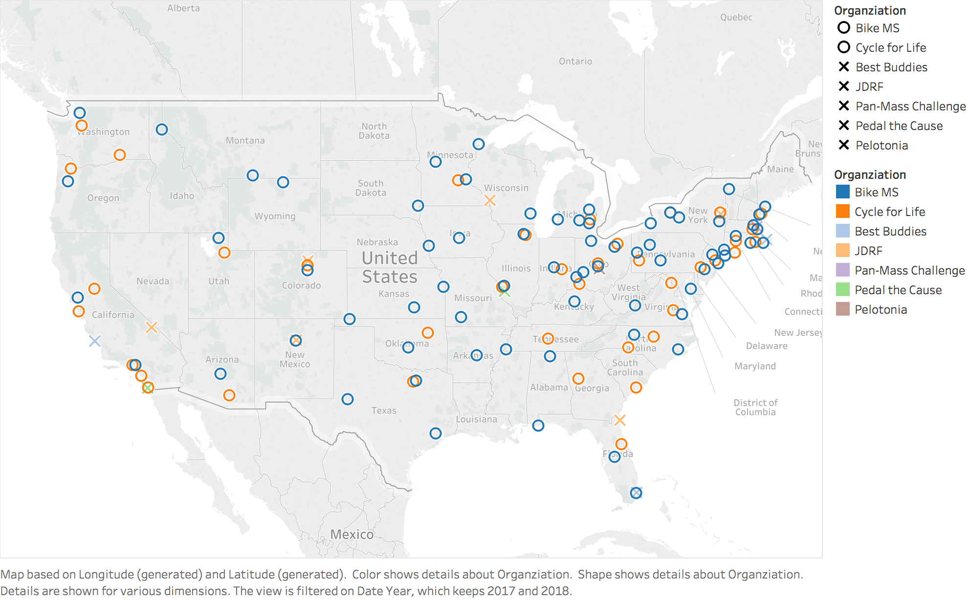

As depicted in the graphic, many events take place in the same or proximate locations, thus they compete for both cyclists as funding. Logically, it is sound to assume that a cyclists decides to participate in a singular bike charity each year; their decision is most likely influenced by their convenience of the event, a personal connection to the organizations core cause and mission, and ability to cover the costs of registration and meet the fundraising minimum - if required by the event.

It is necessary to drill down further to see the impact CF Cycle for Life has on Bike MS’s top performing locations. Although having a wide geographic breadth is inherent to Bike MS’s success, it regularly puts on more rides per year in some locations over others. In 2017 Bike MS operated five rides each in Ohio and New York and four in Michigan and Texas. In contrast, CF Cycle for Life has five rides scheduled in California during 2018; this is followed by three events each in New York and California.

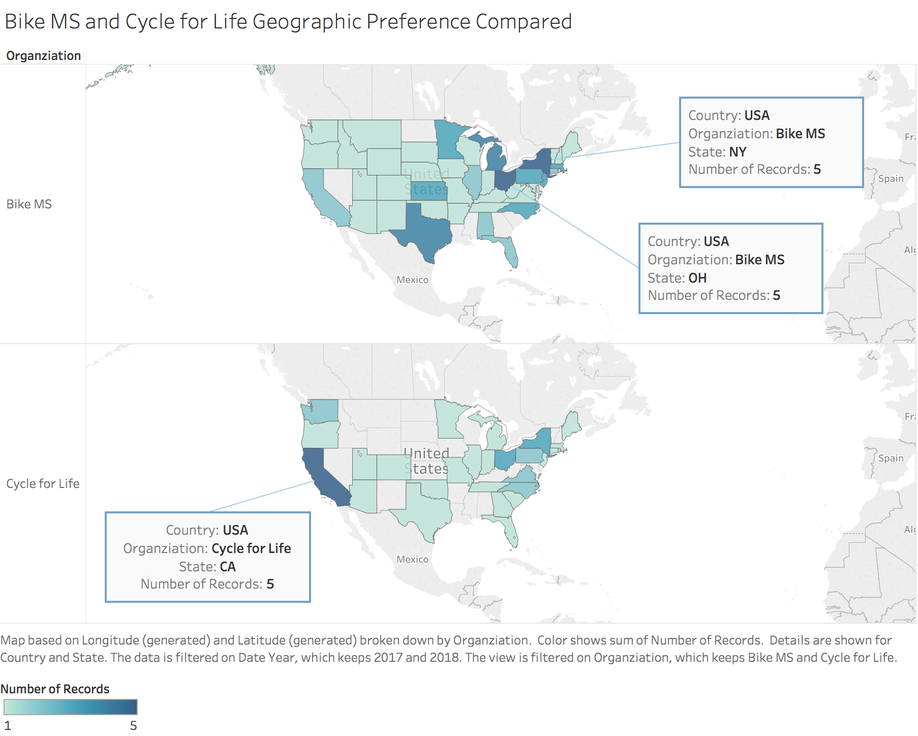

In further evaluation of Bike MS against other major organizations - JDRF, Best Buddies, Pedal the Cause, Pan-Mass Challenge, and Pelotonia - which use biking as a primary form of fundraising exposes a seasonality for bike events.

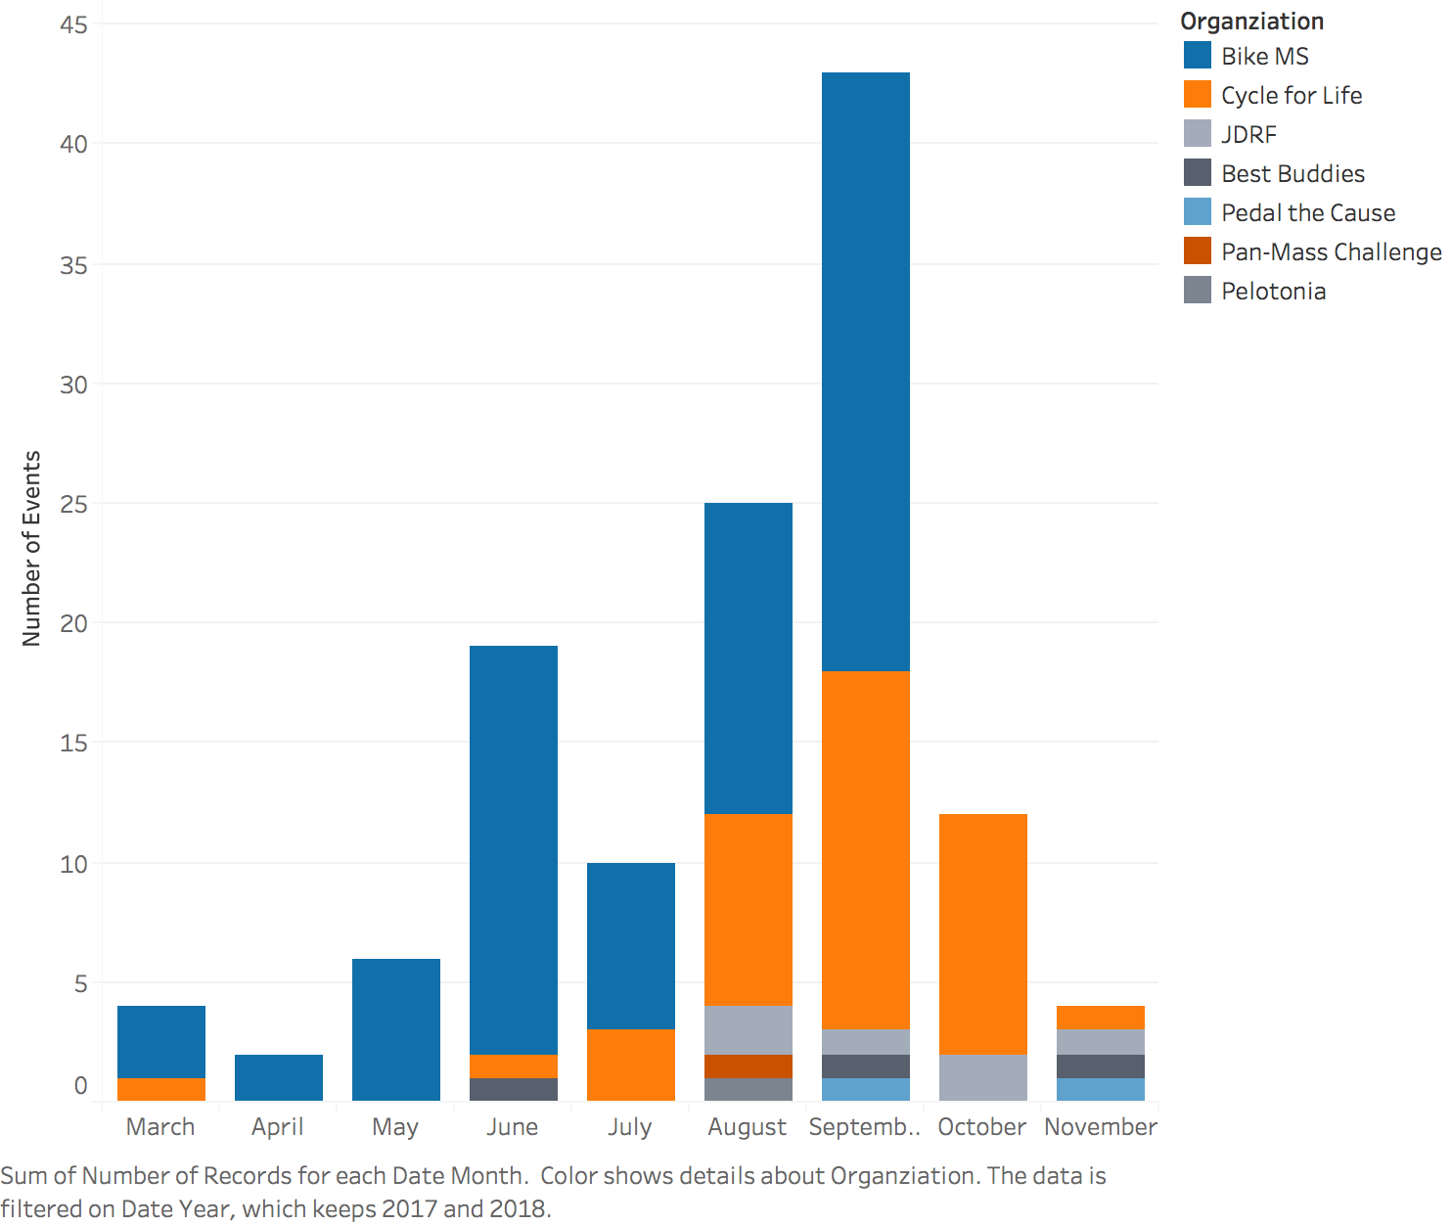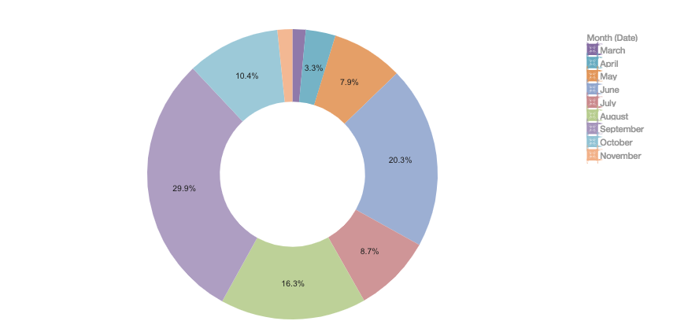

As a substantial number of bike events, 29%, across the previously mentioned organizations occur in the month of September, it is logical to suggest that Bike MS seek to disperse some of its events to other times of year, or initiate a virtual ride event series during winter months to solicit some untapped markets and previously untargeted participants who could help the organization continue to expand and maintain its dominance as the largest charity cycling series.

By placing events at less competitive times per year Bike MS will directly compete with fewer organizations; this will likely result in both an increase in participants and donations. Not only must participants committed to an event in advance, but the plethora of events in the month of September produces a suboptimal market for participants to fundraise in. Donors may be asked by multiple participants to donate and implies two likely outcomes: the donors diffuse the amount they would normally donate to one donor to the multiple participants, or they give all of their funds to one participant and reject any other appeals for contributions. All of these negative impacts are further exacerbated by the fact that many of these events occur in close proximity to one another.

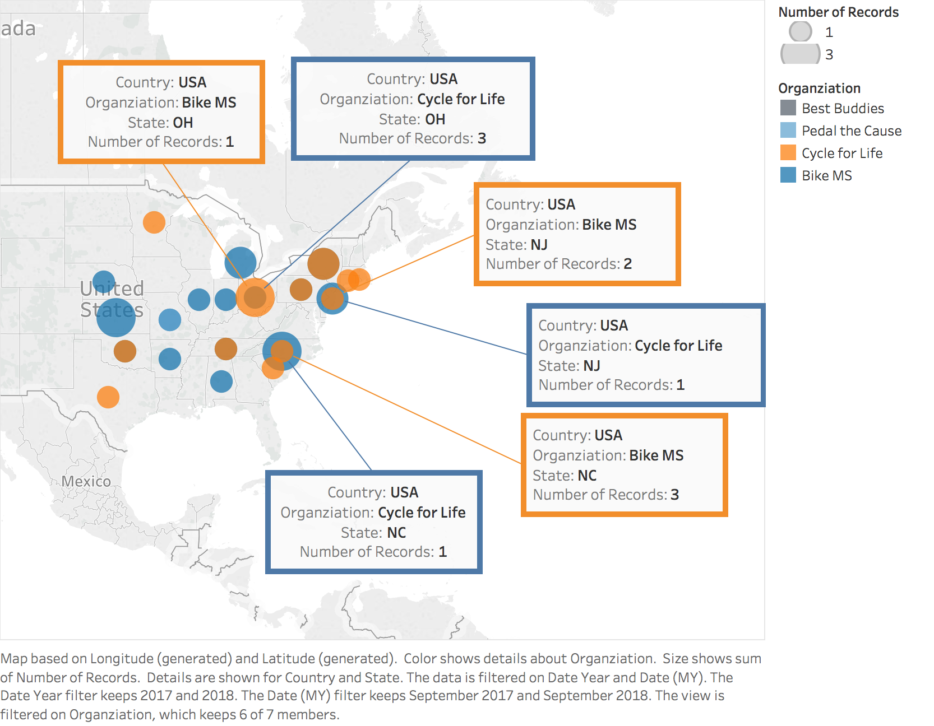

The above image illustrates a few of the overlaps which parse opportunities in North Carolina, New Jersey, and Ohio for both CF Cycle for Life and Bike MS in the month of September. The effect on Bike MS’s top markets is further documented in the decline in both teams and revenue in recent years; this is likely connected in some part to the increase in bike charity fundraisers from other organizations.

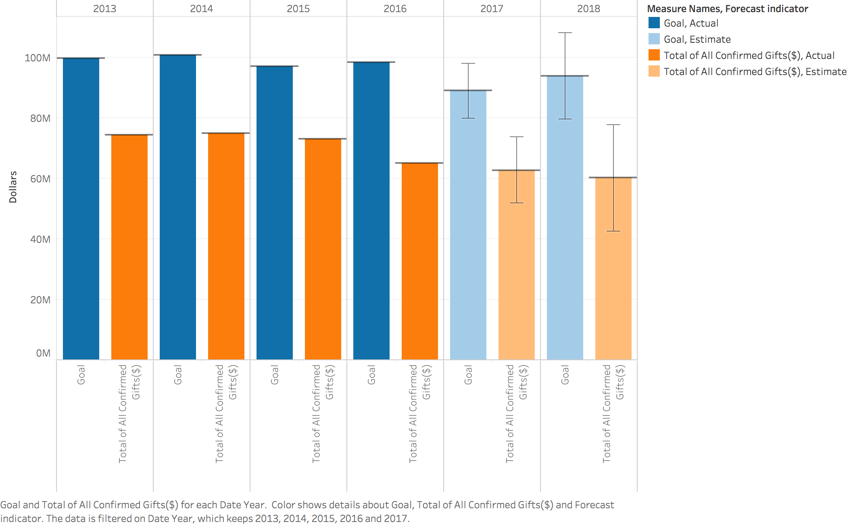

Digital & Social Acquisition

**Opportunities for Investment in Digital Marketing**

Digital Marketing has been categorized by three Platforms - Display, Search, Social. The key criteria for a successful advertising campaign is the inverse relationship between CPA and conversions that is the higher conversions at lower CPAs .

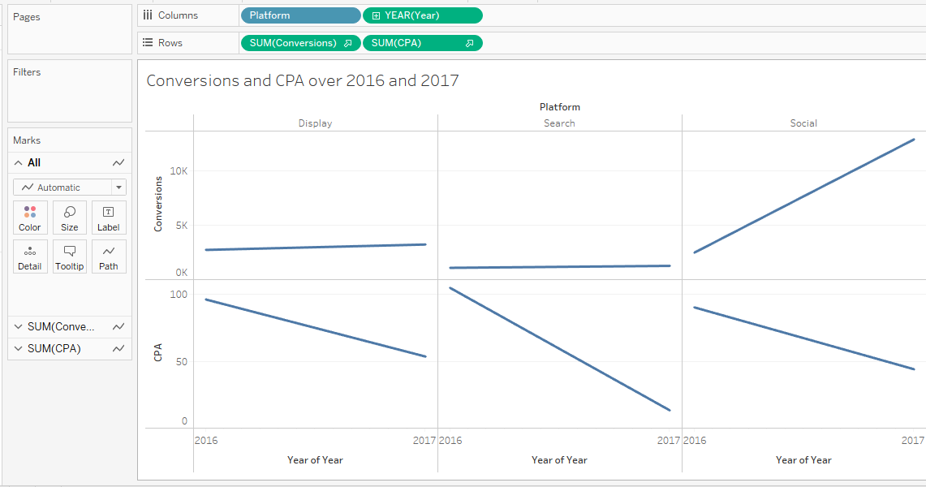

Let’s dive deeper into sub categories of platforms and their performance :-

Facebook which comes under social has performed the best and is the source of greatest digital marketing investment by the CPA and Conversions (click through and view through) and improved over the years.

Instagram has shown the largest improvement from 2016 to 2017. Hence, also being a good investment opportunity.

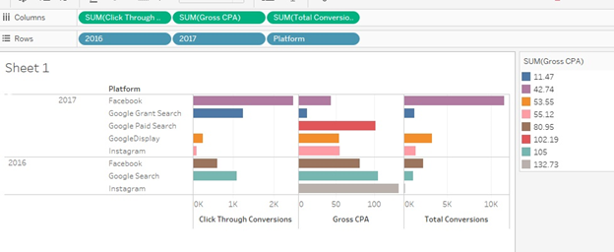

The highest ROI is a factor of above stated relationship. Hence, social platforms having the steeper curves for both CPA (negative slope) and Conversions (Positive slope) have shown the greatest ROI. Hence, Social platforms give the highest ROI. Also, the linear relationship between gross spending and impressions indicate that the higher we spend the higher impressions can be expected. The month of July in 2017 gave us the highest ROI due to the peak spending the month before. Hence, it also indicates that marketing for a particular event should peak a month before the event date.

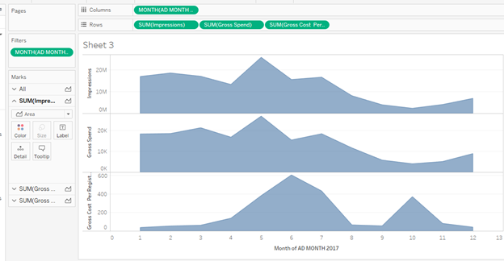

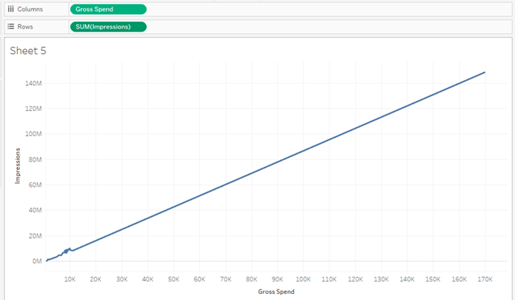

**Tactics & Behaviors Driving Fundraising**

Firstly, we see that the majority of the donations are made not at the time of the donation but after the registration date and before the event date.

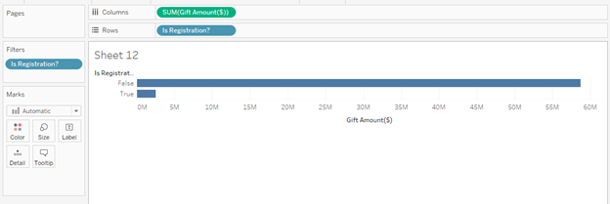

We see the major of the those “FALSE” (donations post registration ) donors fall under the category of Two-Day cyclist , cyclist staying on campus and cyclist using no bus to travel . These are the ones that can targeted consistently for higher donations.

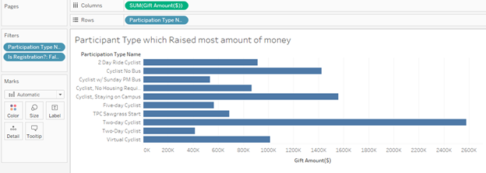

We also see the major of the those “FALSE” (donations post registration ) donors have a friend who has MS and relative who has MS. Hence, ads could be targeted to the friends and relatives of the people who have MS. They more likely donate in the period leading to the event.

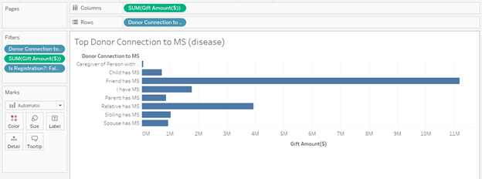

We also see the major of the those “FALSE” (donations post registration ) donors are from the state of Texas. The darker shades of blue have higher chances of donating more amount in the period leading to the event.

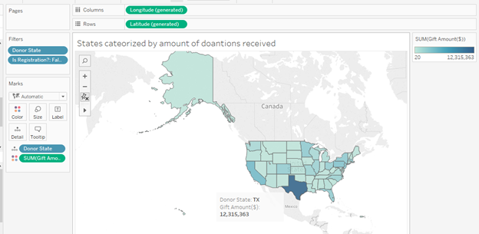

Additionally, we see the major of the those “FALSE” (donations post registration ) major donations are made directly using the weblink to make the donations but a small yet valuable donation is made by clicking on the links in email and forwarded email. Campaigns can be run for to increase the email forwarding and increased emailing to registrations who haven’t donated at the time of registrations can increase the fund collection.

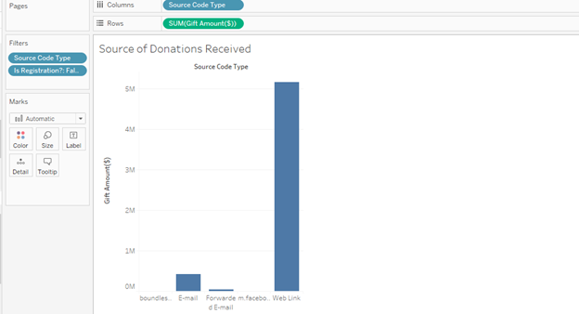

The visualization below conveys gender wise amount of donations made in specific months for the top 10 events also based on the amount of donation collected in 2017. Though most of the events are taking place in the month of September, major of the those “FALSE” (donations post registration ) , the donation peaks in the month of April for both the genders.

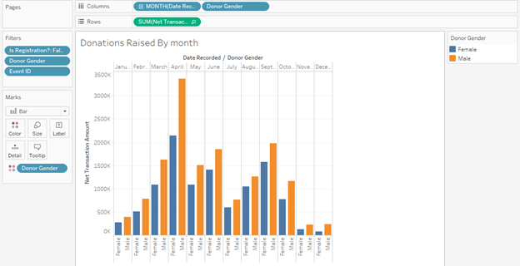

The below is the proof of most of the registrations taking place in the month of September.

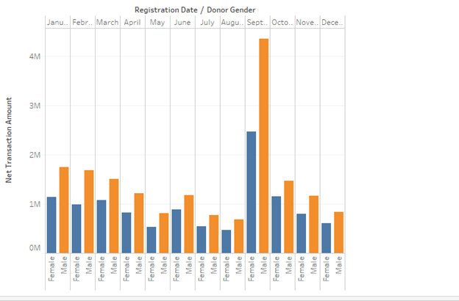

**Linking Behavior and Fundraising**

Firstly, the performing teams in terms of donations made make it directly through the weblink and the second highest source of link being the email.

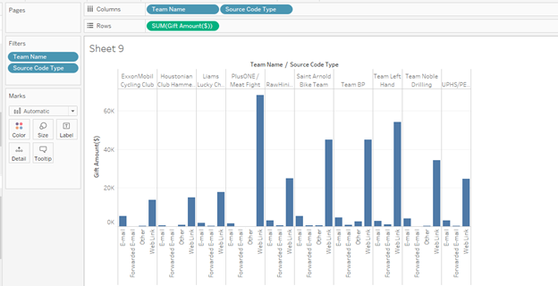

Most of the funds are raised through online payment methods as we can see from the visualization below.

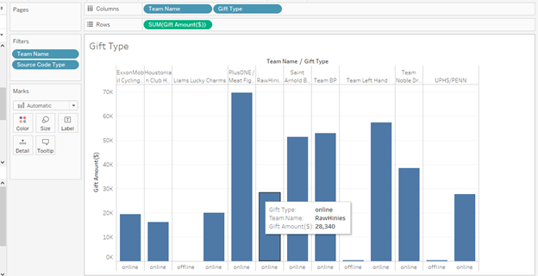

The same visualization for all the teams except the top fundraising team proves that fundraising tools used by MS doesn’t have significant impact on the donations.

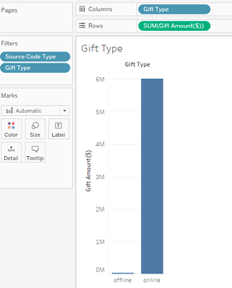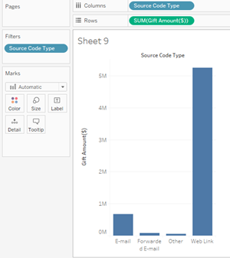

**Turning it Around**

Firstly, we can see from the google analytics dataset that major new users on the website are a result of direct link and organic link combined then any of the advertisement platforms that is social, paid search and display.

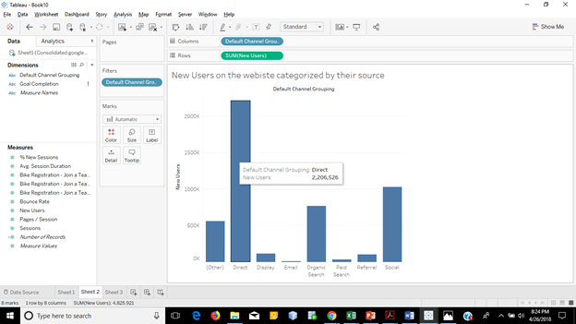

A very important insight we see that the new user bounce rate (one page session) is really high of the social compared to the new user traffic it is attracting. Hence, showing signs of ads not being targeted well.

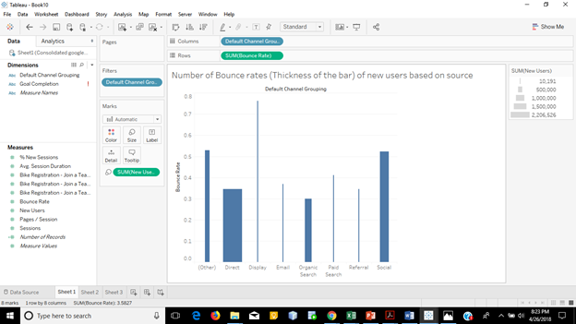

We can again see that the average session duration for the new users through social platforms and paid search which form the key component of paid advertisement . Again indicating that the new user didn’t find anything relating to their preference/likes to spend more time exploring and knowing about the event.

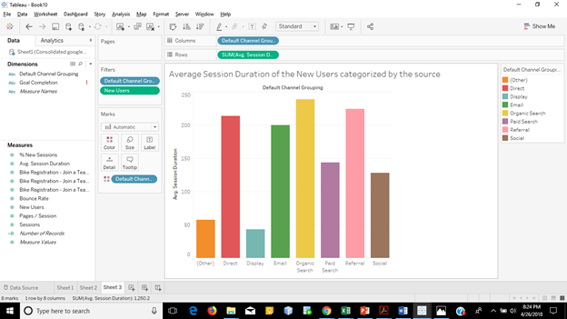

We can also see the top states in terms of number of new users and top amount of average session time spent are different from the top states of highest CPA that is again a result of mistagrted advertisement campaigns.

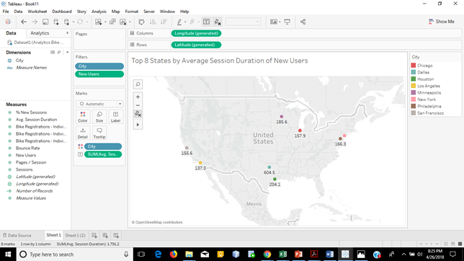

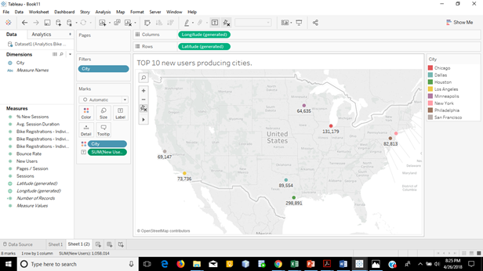

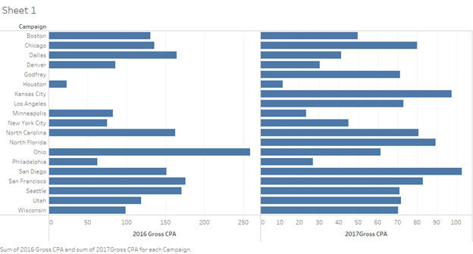

The conversion funnel diagram at the time of the dataset formation indicates that search results of the team could be improved as most of the users exit after the search results are displayed.

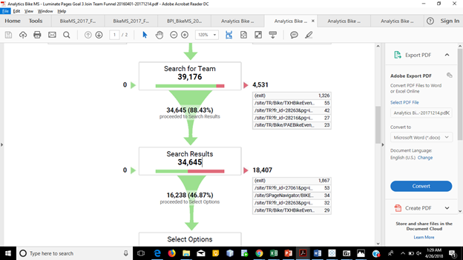

Also, the team page and and get started/Register page has seen a lot of exits. They demand improvements too.

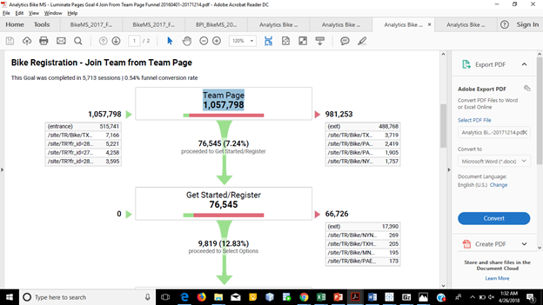

Overall despite increasing digital advertising spend, acquisition continues to trend downwards. The dataset indicates that it is predominantly an issue of needing better targeting and a conversion rate issue that needs to be addressed through the registration process on the website. The targeting of advertising needs to done based on the data of the donations, participants and events combined and not just based on CPA which the data has shown.

The funnel diagrams indicate that website needs to be optimised in the areas of search results by handling unfound search results, auto correct and auto complete. Also, the steps/pages leading to conversion can be reduced by merging steps such terms and conditions can be merged with registration details and Team Page can itself have join or register a new team instead of it being separate individual steps so that if the team is not found in the search results then they can create a new one instead or register themselves individually first and join the team later.

Additional Insights

**Corporate teams are not the only big income generators.**

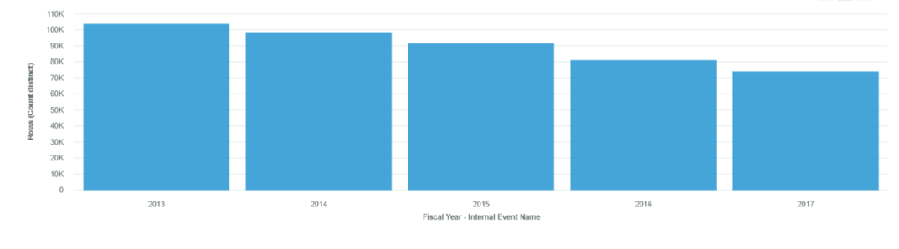

From the above we can visualize that the participant count has been progressively decreasing per year over the last 5 years.The Online-offline trend mix over the fiscal years have been illustrated below:

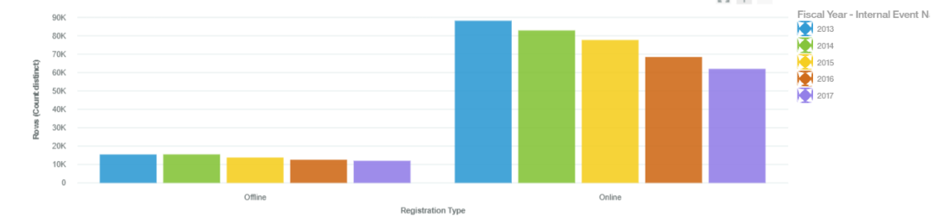

From the above we can clearly visualize a decreasing trend for both the online and offline Channels for registration. The regional distribution of participant population over the years is as shown below:

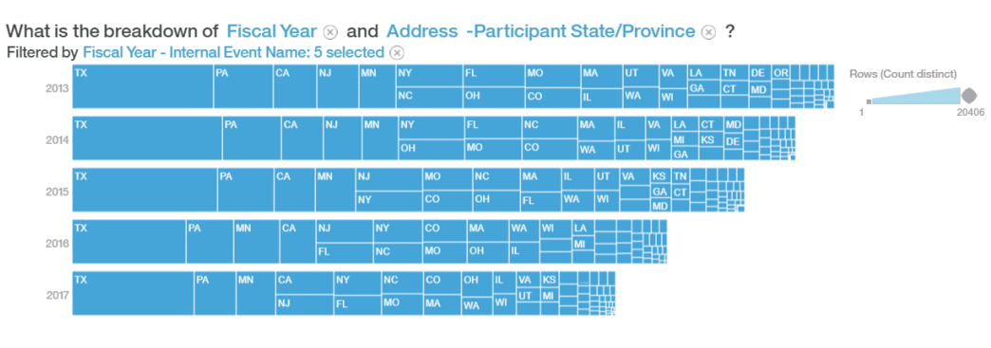

Basis the geographical spread of participant population, we look at of Total income spread over the last five years for the Bike Ms event organizers from those regions:

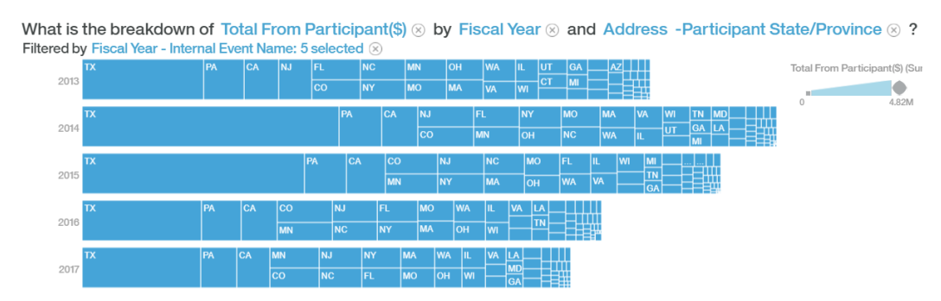

From the above two graphs we can clearly visualize the Texas region as being the greatest contributor both in terms of number of participants as well as the Total Financial contribution per fiscal year and can be looked at more closely to model for other regions in the coming years.

The Graph Below does a further deep down analysis on the number of contributions made from participants as well as non participants to segregate the trends for incomes under each category over the years and it clearly shows the declining trends for both categories of contributions and more specifically the number of donations from non participants showing a steeper decline. This leads us to examine the need for branding the event beyond the participant category,for their employers, family and acquaintances contributing on behalf of the participants.

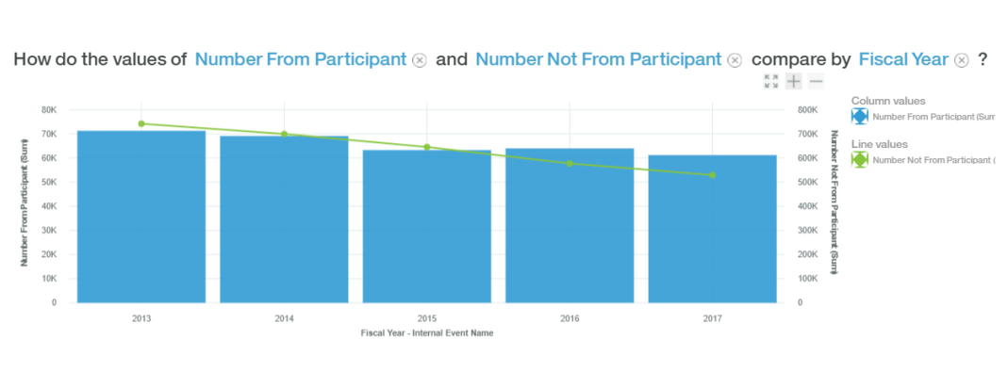

Also, we can look at the trend of repeat participants over the years to spot the declining trend which has been a pain point for the event organizers as this alludes to the idea of treating the acquired customers with care, the first time they participate in the event, through the right branding and necessary services.

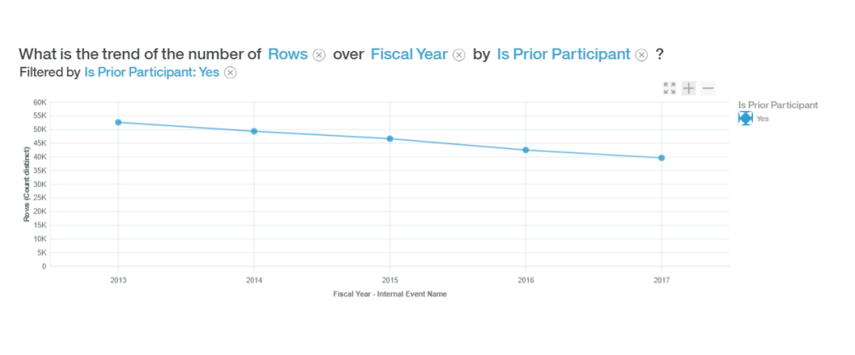

Also, If we dig deeper into the Participant Type Trends over the years, we see that while there are no volunteers showing up post 2013 and the number of Cyclists have been progressively declining over the period, the Virtual Cyclist participation numbers have been more steady over the same period with no alarming decline exhibited. So, this provides us with some food for thought into the underlying reasons for such contrasting trends.The possible reasons could be no registration fees charged for a virtual cyclist due to their physical inabilities to participate in cycling events but with a willingness to support the cause through their networks etc.

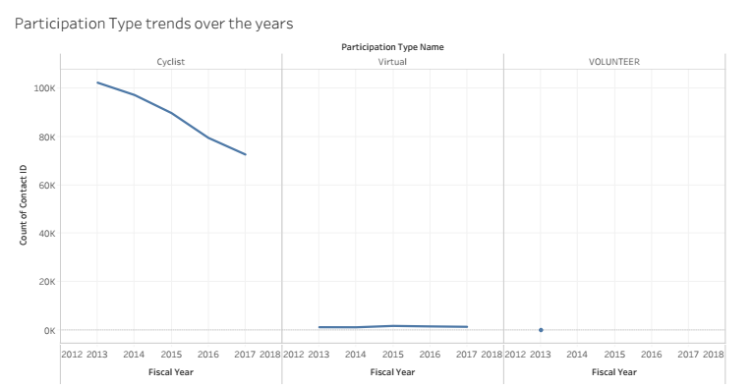

A virtual cyclist is a person who joins a team to fundraise on its behalf but does not cycle. There is no fee for joining.

**Sample Predictive models derived from the data:**

The predictive strength indicates confidence of the prediction model associated with the fields that appear as predictor for the target parameter. The higher the predictive strength of a field, the stronger the correlation it has with what is to be predicted.

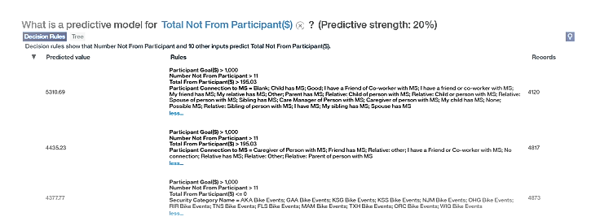

The decision tree for the above predictive model is a shown below:

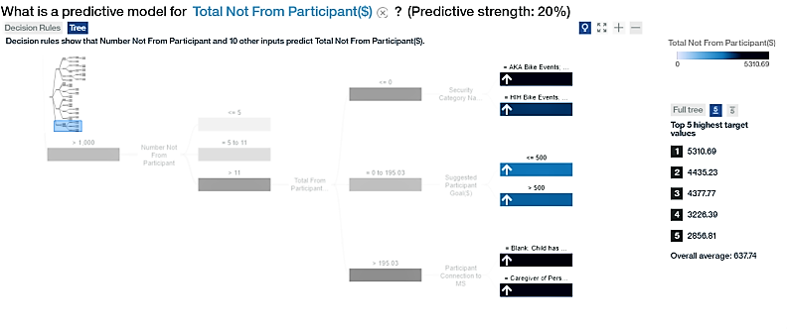

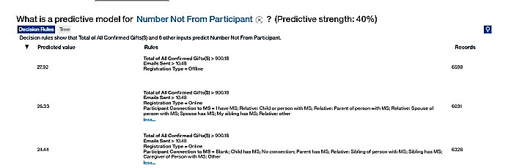

The decision tree for the above prediction model:

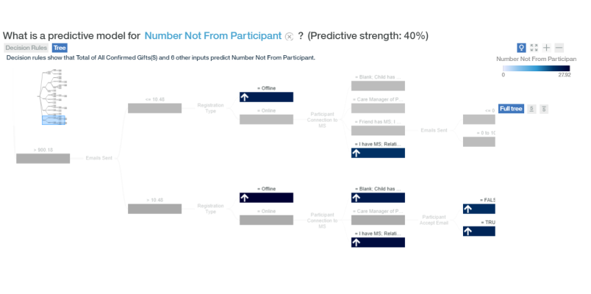

## **Part V: Recommendations and Conclusions**

A majority of the recommendations are given based on the answers to the questions. BikeMS should focus on its highest revenue generating state - Texas and should focus on the Oil & Gas company sector more. If we could get more details about the nature of the events of some particular revenue generating areas, we could mention growth opportunities based on that aspect.

Recommendations to MS Bike for advertising and analytics to do is to collect advertisement data by linking conversions with registrations which will enable to have stronger targeted ads. Also, to collect data on the type of content being advertised. Moreover, categorize ad campaigns by registrations and donations. If more analysis could be performed we would have liked to relate the converted registrations, converted donations and to specific ad campaigns. We would also like to analyze google analytics data activity wise that is registrations and donations.

A Few key areas we would have liked to look into:

* The number of recorded transactions as part of the “Total of all Confirmed Gifts” that didn’t eventually materialise and should have been taken off from either the “Total from participants” or “Total Not from Participants” lists to arrive at more accurate results and predictions.
* Exact details of the payments made on behalf of the Participants, whether the same was made by the Participant's employer, family, friends etc to understand the distribution of contributions made against each participant more explicitly.

From the Predictive rules ,we can see that there is a fair amount of correlation existing between Participant Goals, Number of contributions made on behalf of individual participants,Nature of Connection between the participant and the MS event, Total contributions made by the participant himself/herself to the “Total Contribution” that can be expected from the Not from Participant category. In other words the drivers for non participant contribution would be the Participant goals,Number of contributions made on behalf of individual participants,how’s the participant connected to the MS event to make some predictions or generalizations.

Also, one of the other rules discovered was that the Number not from Participants would be driven by the Registration type-Online or offline,the number of emails sent to participants as well as the commitment made during registration phase in terms of “Total of all confirmed gifts” to the MS event.

Thus the organizers should focus on a two pronged approach- They need to ensure quick wins through markets which are mature for them like Texas /PA/California focusing on Oil & Gas , Banking & Financial Services sectors to encash upon their brand visibility in those contexts.They also need to simultaneously work on a long term strategy of developing new markets basis the success models in their quick win sectors and markets, to stay ahead of the competition through the predictive models and forecasts developed basis the study of their success stories so far.

|  |  |  |
| --- | --- | --- |
| Team Member Name | Dataset | Questions |
| Anshu Jana | Bike Teams | 1, 6 (Corporate Acquisition) |
| Erika Eagen | Events | 2,7 (Corporate Acquisition) |
| Deep Mitra | Participants | 3,4,5 (Corporate Acquisition) |
| Helen Galindo | Donations | 1,2(Corporate Acquisition) |
| Arihant Jain | Google Analytics  Bike MS Advertisements | Digital and Social Acquisition  (Part B) 4 Questions |
| Glenn Pepito | NOTHING  (Auditing the course) | NOTHING  (Auditing the course) |